Booklet
Y9
Day

Wednesday 21st September 9am – 3pm
Name:
Year: 9
Tutor:
What do I need to do?
While you are working from home today you will follow your timetable as closely as possible.
- Your timetable for the day is below.
- Work through the activities in this booklet.
- You will need access to the internet for some activities. If you do not have this move on to the next task.
- If you finish and activity early you can do the extension tasks at the back of the booklet
Lesson 1:  9:00am – 10:30am | Design & Technology
Break: 10:30am – 11:00am
Lesson 2:  11:00am – 12:30pm | Maths
Lunch: 12.30pm – 1:00pm
Lesson 3:  1:00pm – 2:00pm | Science
Lesson 4:  2:00pm – 3:pm | Extension Activity
End of home learning: 3:00pm

You will need to hand this booklet in and any extra work you have completed to your Head of Year on the school gate on Thursday 22nd September

Design & Technology

Cooking
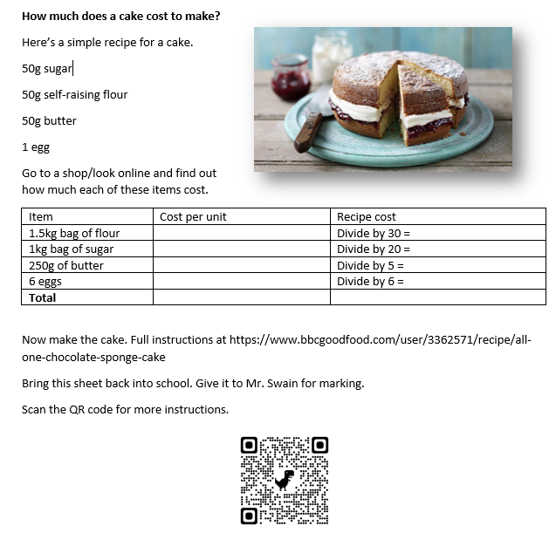

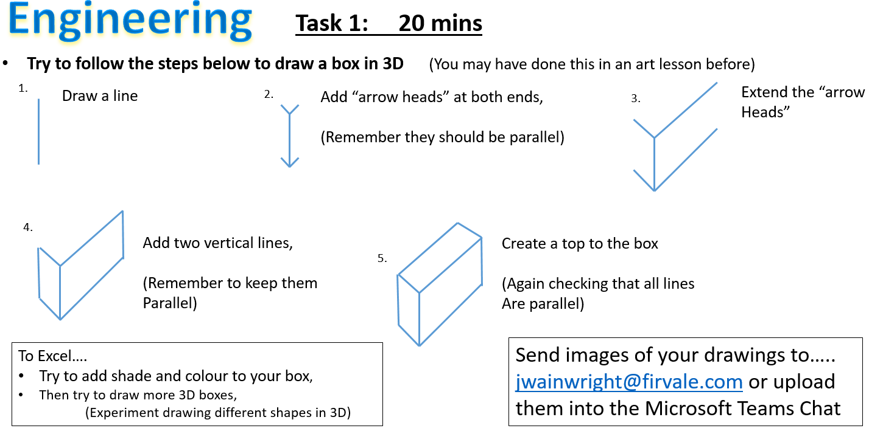

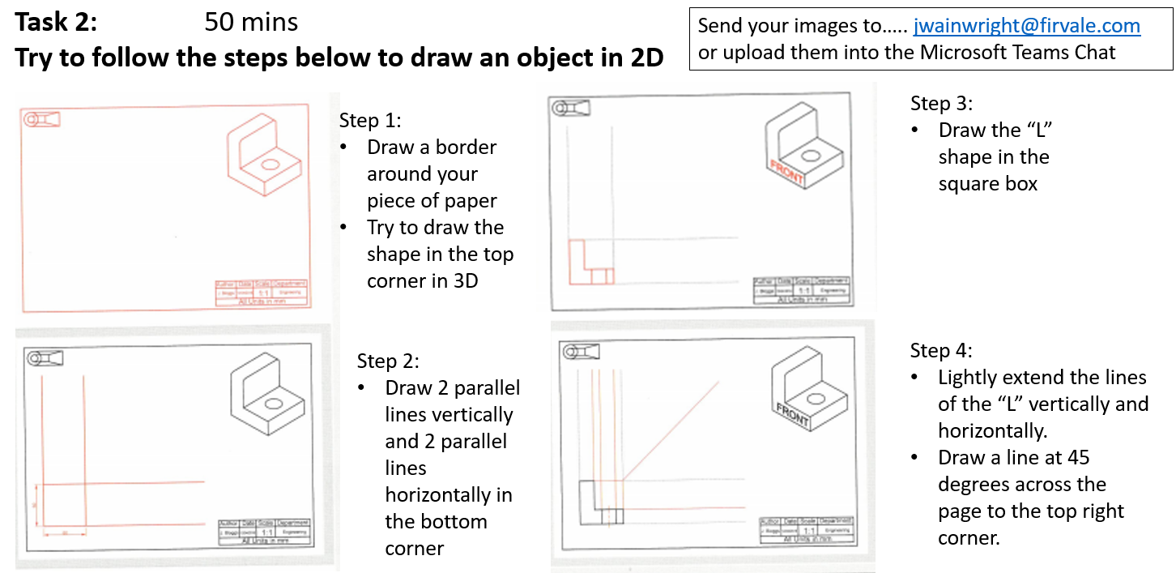

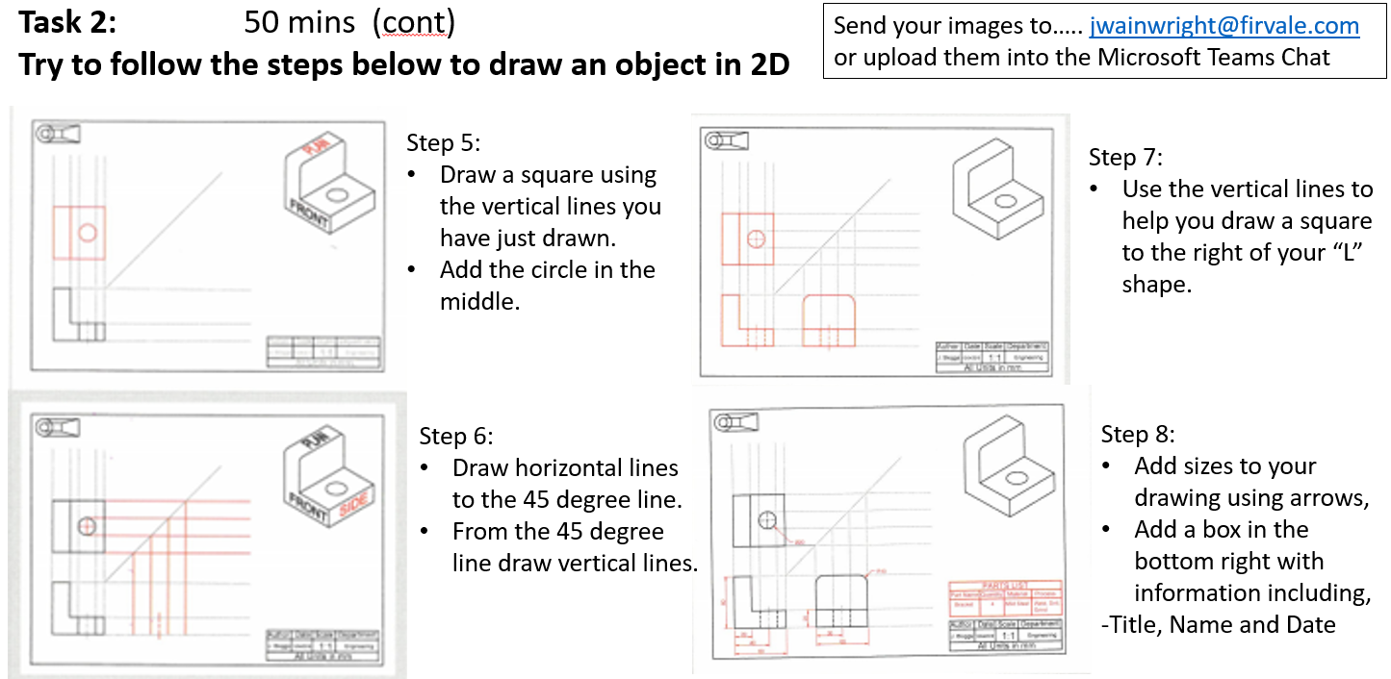

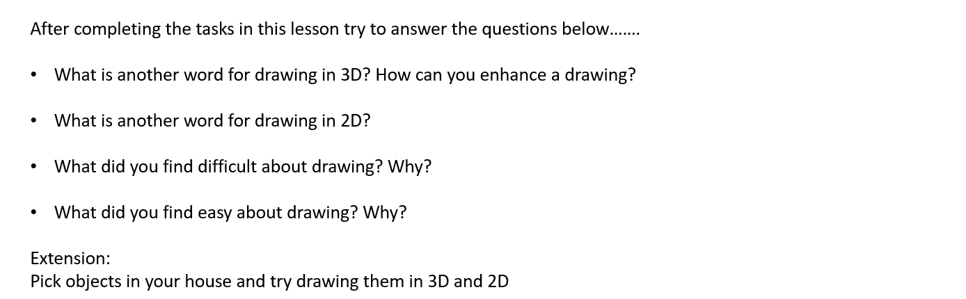

Maths

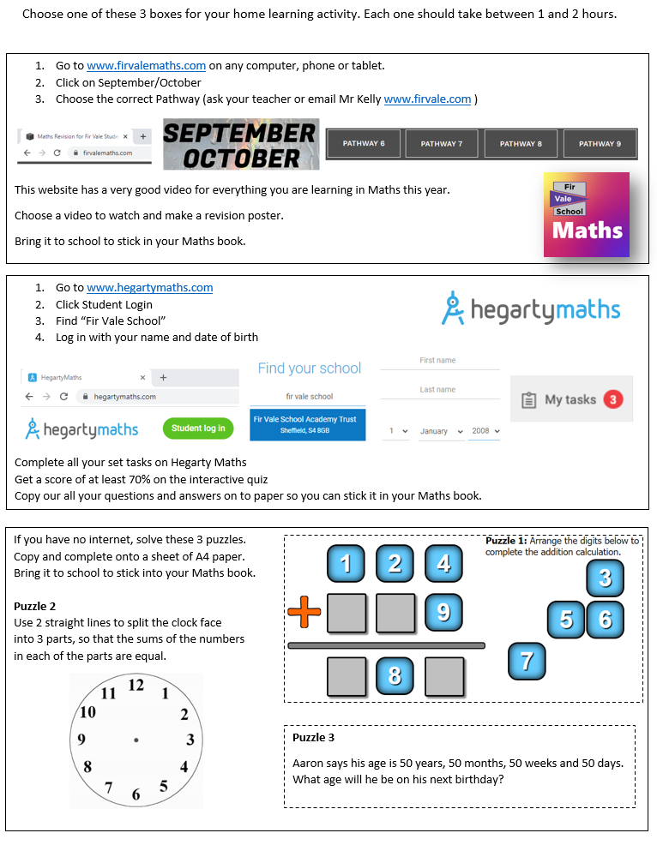

Science

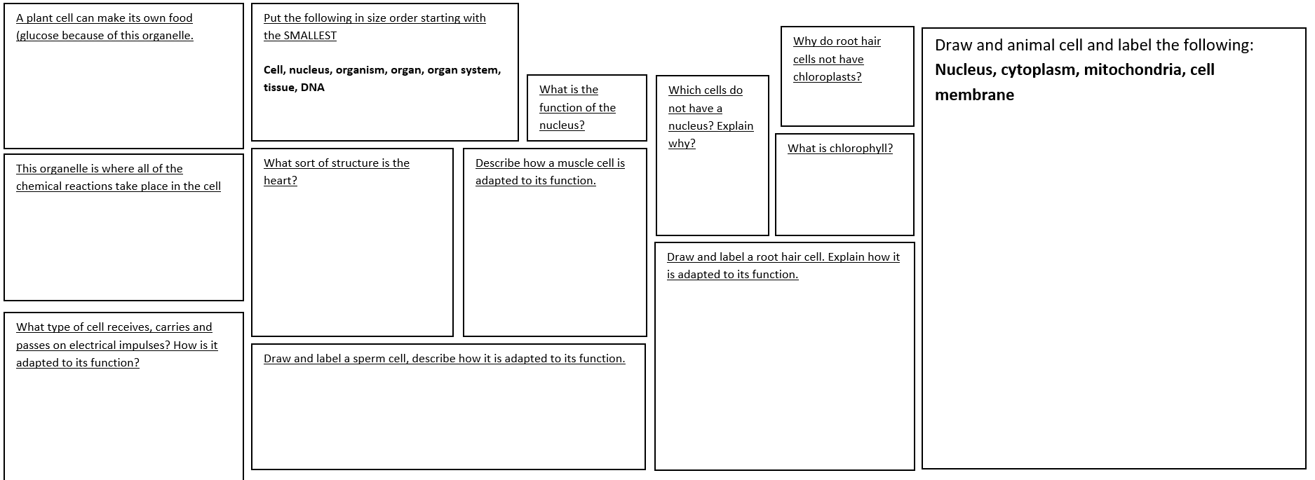

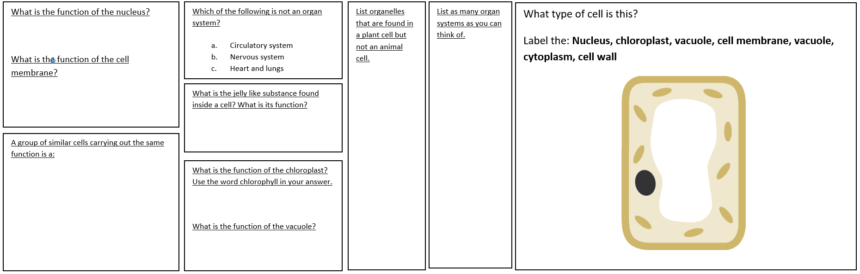

KS3 Cells & System
Extension Activity

