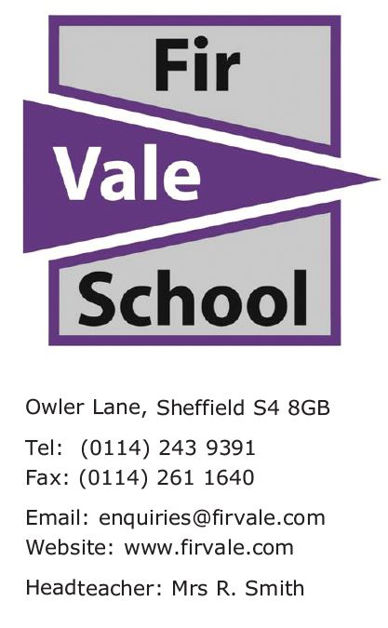
Our Ref: Y8/Y9 ParentsEvening

03 January 2023

Dear Parent / Carer
Year 8/9 Parents’ Event on Thursday 5th January 2023
I am writing to invite you to the Year 8/9 Parents’ Event taking place on Thursday 5th January 2023 at 3:30pm - 6:00pm.
This is an excellent opportunity for you to meet teachers and receive feedback regarding your child’s progress, as well as the areas to be developed over the coming weeks.
It is vital that teachers have the opportunity to discuss your child’s progress and be able to provide you with advice on how you can support them throughout their studies at Fir Vale.
If for any reason you cannot attend the event, please contact the school to arrange an alternative time and date to collect reports and discuss the progress of your child.
We look forward to seeing you on Thursday 5th January 2023.
Yours faithfully,
Miss Hussain - Head of Year 8
Mr Hussain - Head of Year Y9

If you need a translator to understand this please call the school on 01142439391
"إذا كنت بحاجة إلى مترجم لفهم ذلك ، يرجى الاتصال بالمدرسة 01142439391.
Te tumenge kampola interpretos hoj te rozuminen feder ta vicinen pre kada cislos 01142439391

