Booklet
Day
Y8

Wednesday 21st September 9am – 3pm
Name:
Year: 8
Tutor:
What do I need to do?
While you are working from home today you will follow your timetable as closely as possible.
- Your timetable for the day is below.
- Work through the activities in this booklet.
- If you finish and activity early you can do the extension tasks at the back of the booklet
You will need to hand this booklet in and any extra work you have completed to your Head of Year on the school gate on Thursday 22nd September

Lesson 1:  9:00am – 10:30am | Science
Break: 10:30am – 11:00am
Lesson 2:  11:00am – 12:30pm | English
Lunch: 12.30pm – 1:00pm
Lesson 3:  1:00pm – 2:00pm | Ethics
Lesson 4:  2:00pm – 3:pm | Extension Activity
End of home learning: 3:00pm

Science

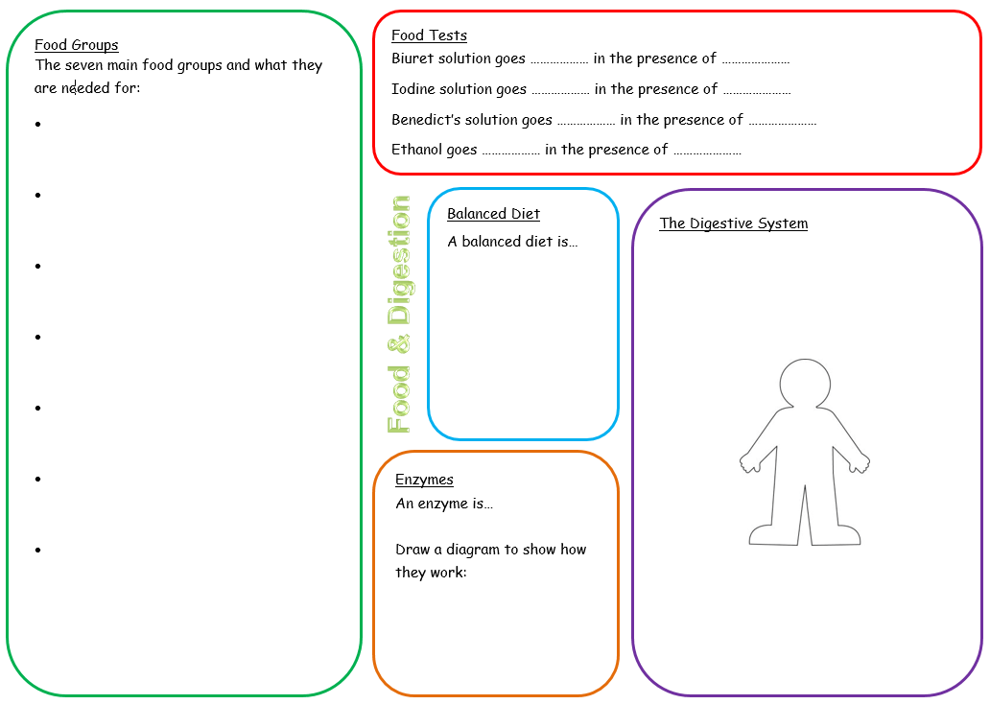
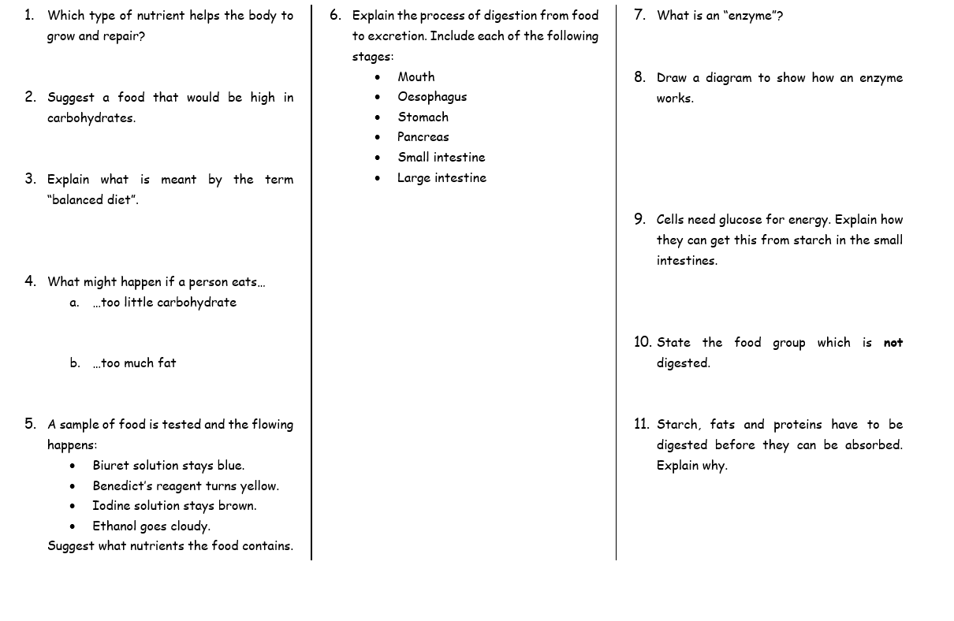

English

Dystopia

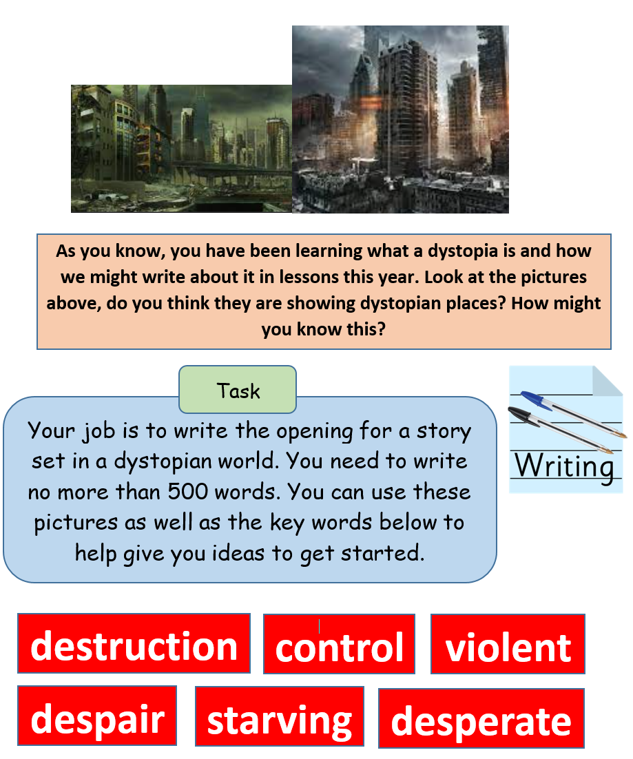

Ethics

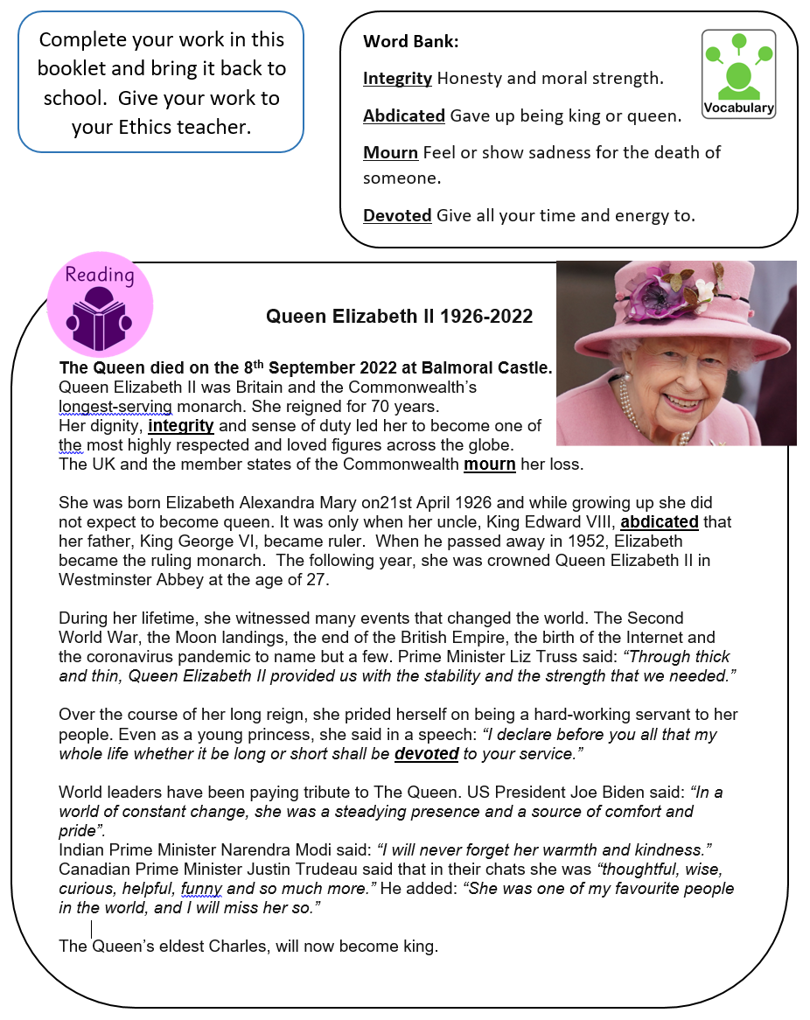
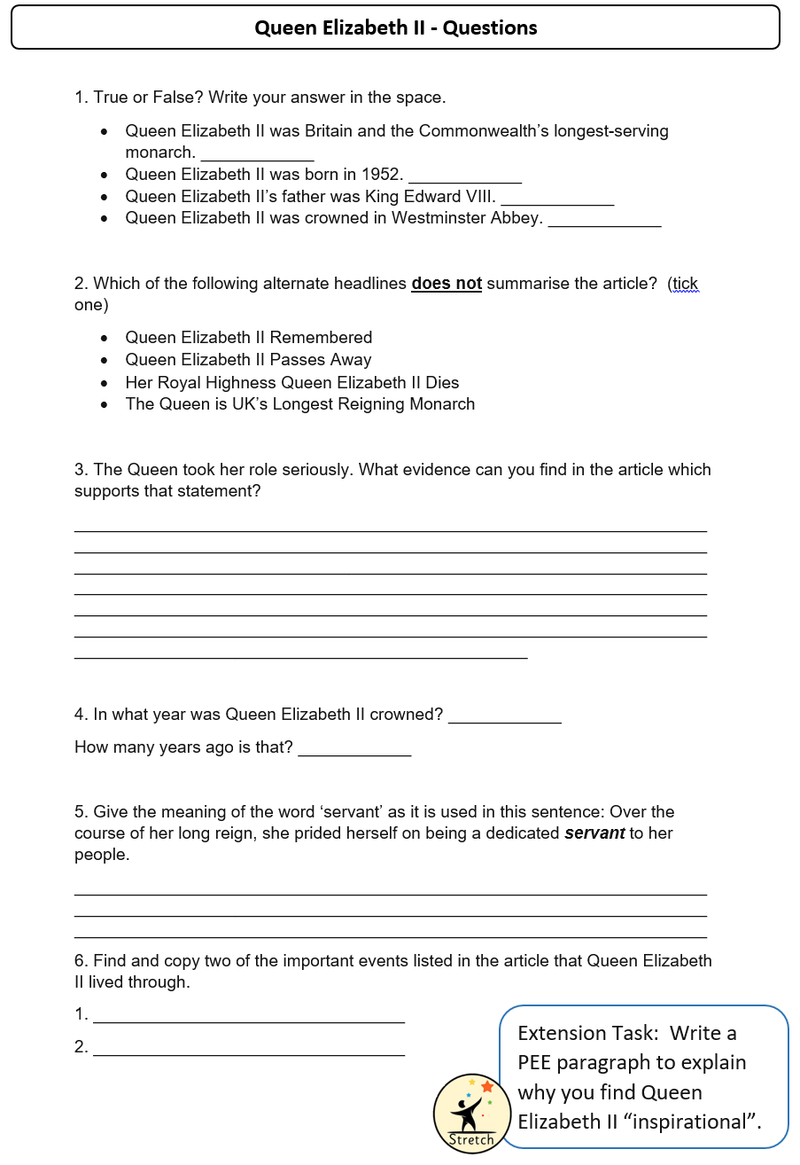
Extension Activity – Reading
