Booklet
Day
Y7

Wednesday 21st September 9am – 3pm
Name:
Year: 7
Tutor:
Tutor:
What do I need to do?
While you are working from home today you will follow your timetable as closely as possible.
- Your timetable for the day is below.
- Work through the activities in this booklet.
- You will need access to the internet for some activities. If you do not have this move on to the next task.
- If you finish and activity early you can do the extension tasks at the back of the booklet
Lesson 1:  9:00am – 10:30am | Reading or Spanish
Break: 10:30am – 11:00am
Lesson 2:  11:00am – 12:30pm | PE
Lunch: 12.30pm – 1:00pm
Lesson 3:  1:00pm – 2:00pm | Dance, Drama or It
Lesson 4:  2:00pm – 3:00pm | Extension
End of home learning: 3:00pm

You will need to hand this booklet in and any extra work you have completed to your Head of Year on the school gate on Thursday 22nd September

Reading

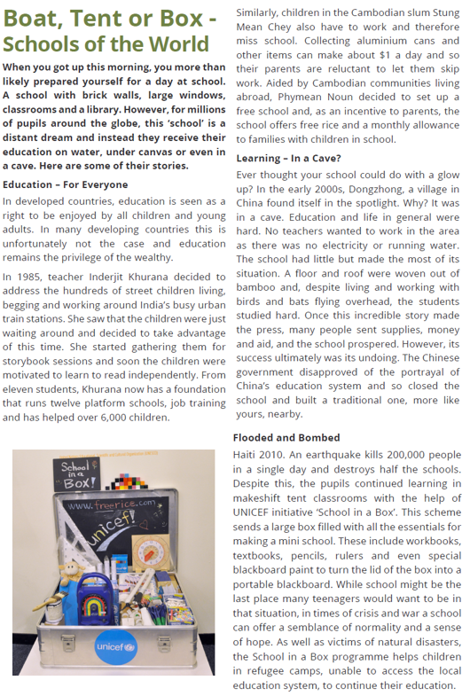
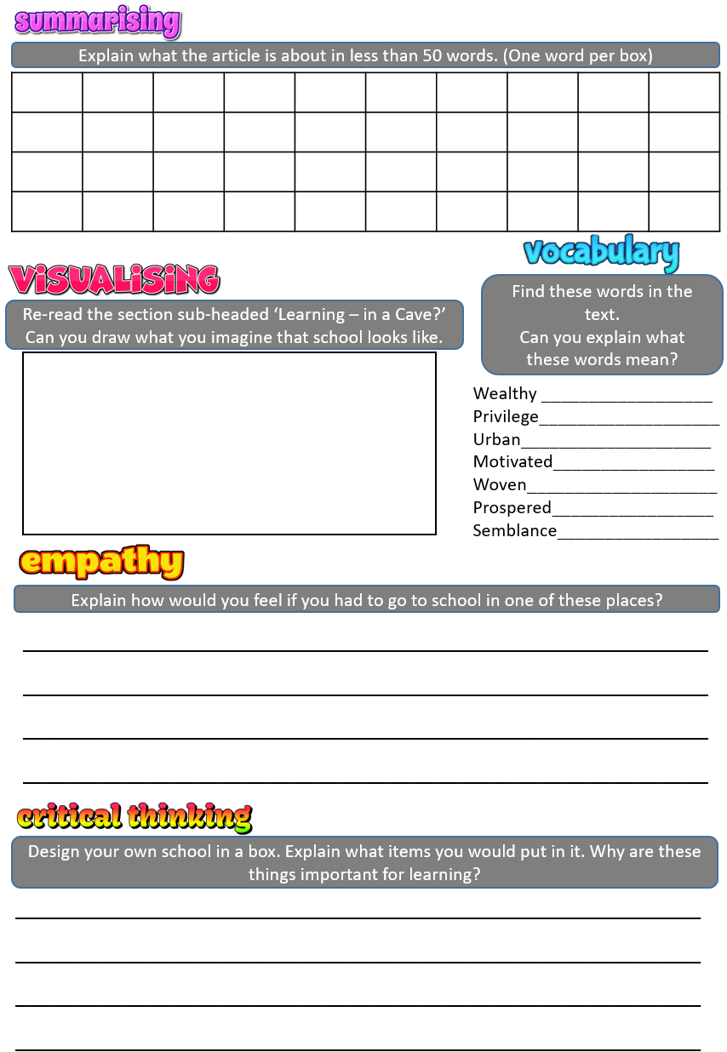
Spanish

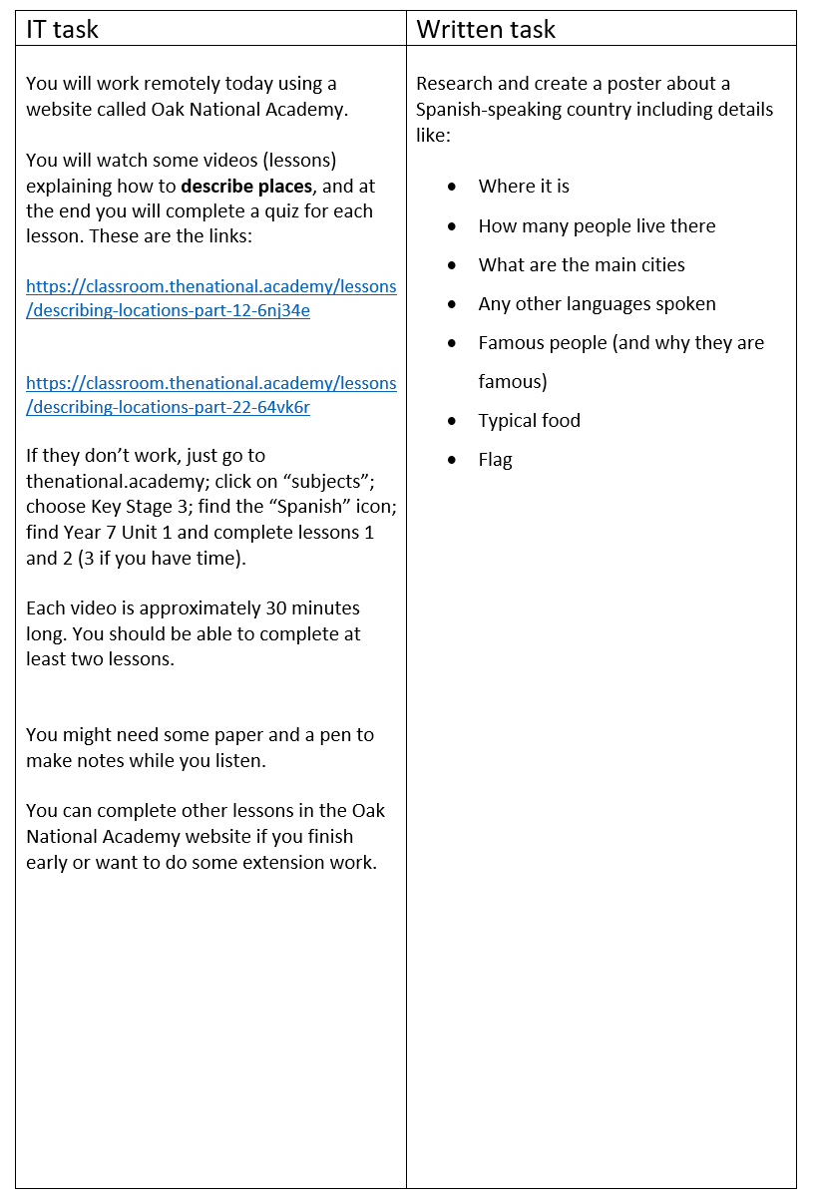

PE

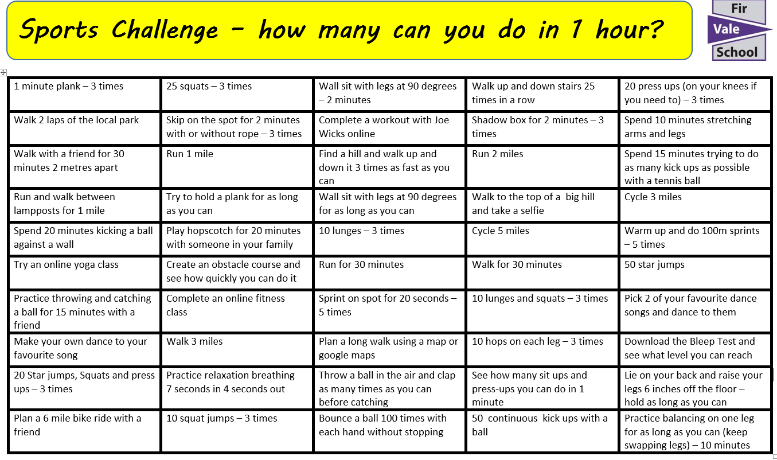

Drama

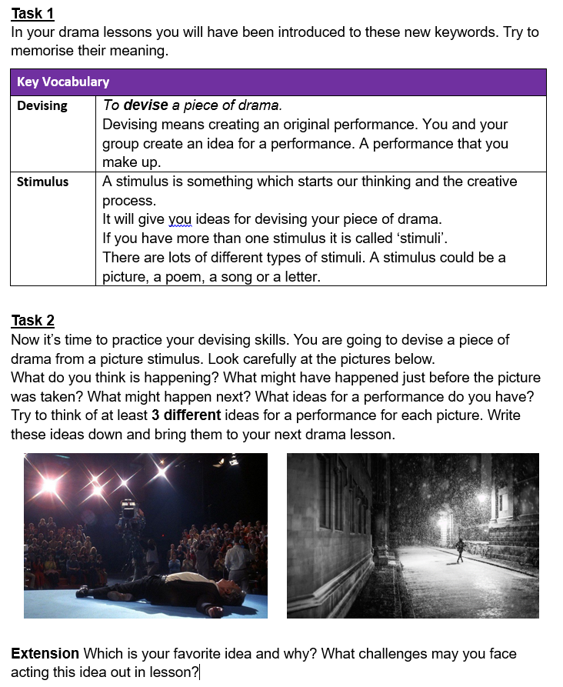

Dance

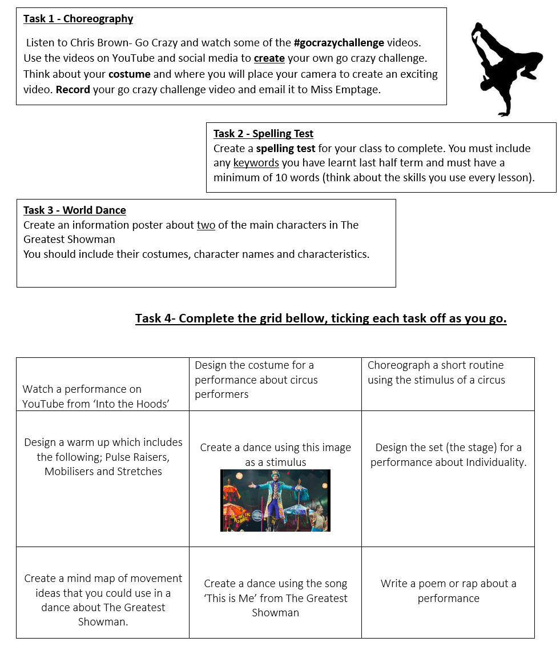

IT

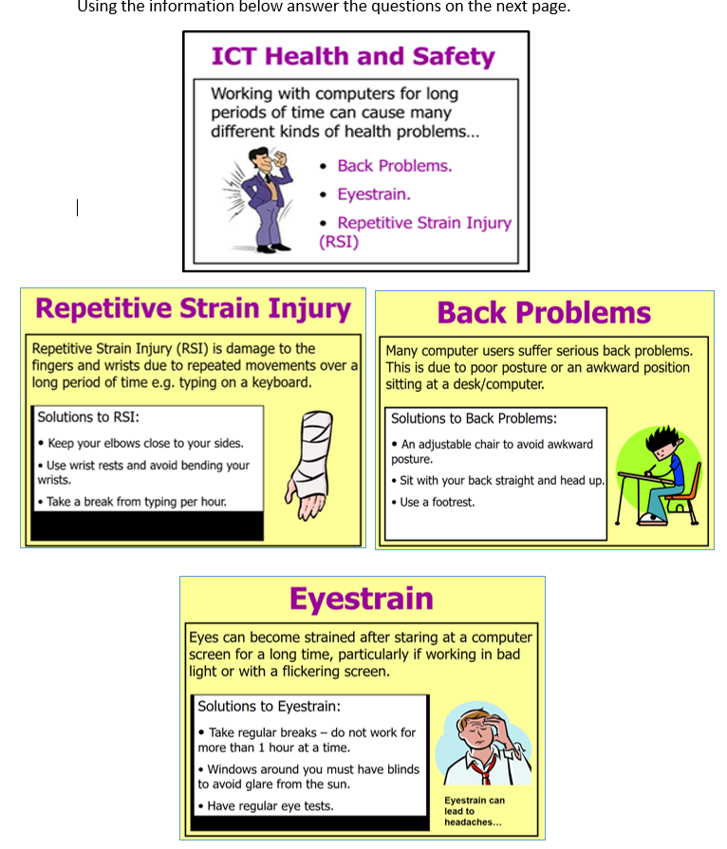

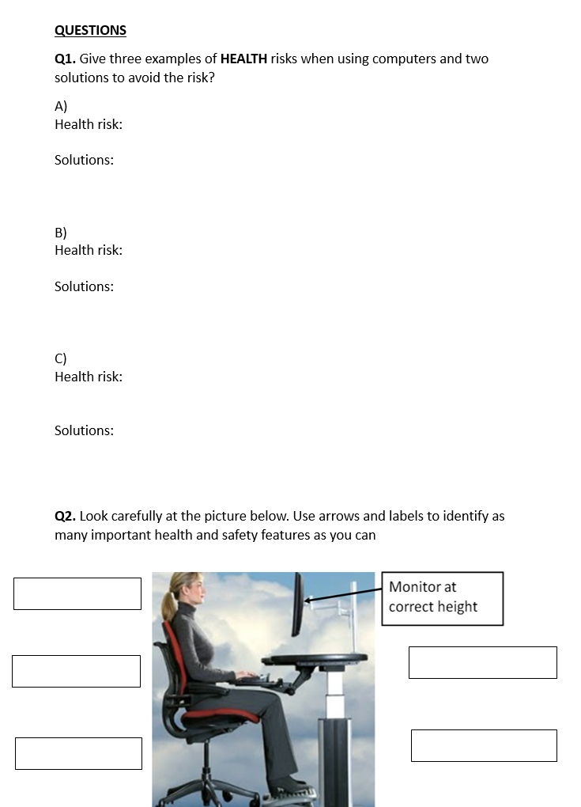

Extension

