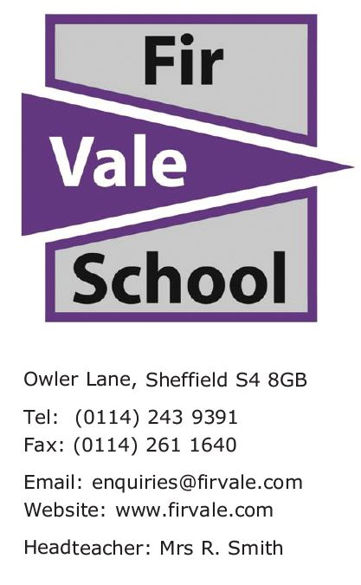
Our Ref: RSM/GOX/Y7HomeLearningDay

08 December 2022

Dear Parent / Carer

In common with many other schools we are currently experiencing high levels of sickness absence with students and staff. This is also the case with the supply agency we use – all of these are experiencing unprecedented level of absence.

As a school we are used to dealing with difficult situations and we always have a contingency plan ready. If staff levels are at such a low level that we have to close the school for a day we will let you know via text, Facebook and the website (Fir Vale.com). The procedure would follow the same as for a ‘snow day’. This is something that we would only do in extreme circumstances.
Currently we do not need to fully close for the day but we know today that we do not have enough staff for all students to be in the building tomorrow. Therefore if your child is in Year 7 they will be working from home on Friday 9th December 2022.
All students in Year 7 will be sent home with work to complete.
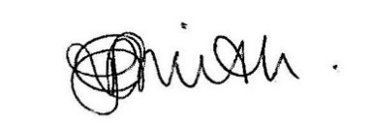
Yours faithfully

Rachel Smith
Headteacher

If you need a translator to understand this please call the school on 01142439391
"إذا كنت بحاجة إلى مترجم لفهم ذلك ، يرجى الاتصال بالمدرسة 01142439391.
Te tumenge kampola interpretos hoj te rozuminen feder ta vicinen pre kada cislos 01142439391

