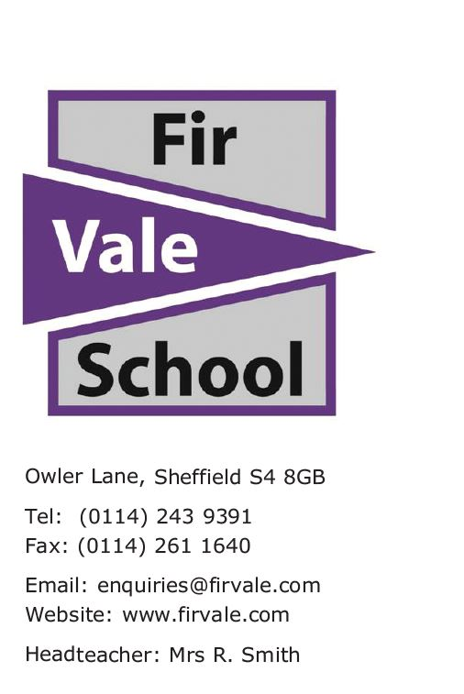

Dear Parent/Carer

We would like to invite your child in for our ‘**Welcome Day’** visit at Fir Vale School on

**Tuesday 8th July 2025 9am – 3pm**

**At 9am they will be welcomed into the school to meet some key members of staff, experience some lessons and receive important information to help them with their transition to Fir Vale School.**

* They should arrive at Fir Vale School main school gates from 9am
* Your child will need to wear their Primary uniform to help with identification during the sessions. They should also bring a school bag and equipment with them
* Free lunch will be provided for your child but you may wish to provide this yourself or supply additional snacks. Please inform us if your child has any food allergies by emailing enquiries@firvale.com
* Send your child with any necessary medication they require for the day
* They will have been provided with a Fir Vale water bottle in their welcome box. Free water dispensers are available to use so they can bring their Fir Vale water bottle

We are holding an additional Parent/Carer drop in between 3pm and 4pm on this day *(8th July 2025).* This is for any parents who have not ordered their child’s **free** uniform.   
**If you have already attended one of the drop in sessions, it is not necessary to attend.**

Yours faithfully

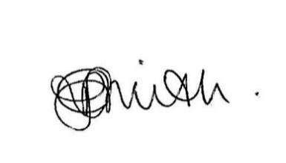

Rachel Smith

Headteacher