Booklet
Day
Wednesday 21st September 9am – 3pm

Y10

Name:
Year: 10
Tutor:
What do I need to do?
While you are working from home today you will follow your timetable as closely as possible.
- Your timetable for the day is below.
- Work through the activities in this booklet.
- You will need access to the internet for some activities. If you do not have this move on to the next task.
- If you finish and activity early you can do the extension tasks at the back of the booklet
Lesson 1:  9:00am – 10:30am | English
Break: 10:30am – 11:00am
Lesson 2:  11:00am – 12:30pm | Maths
Lunch: 12.30pm – 1:00pm
Lesson 3:  1:00pm – 2:00pm | Option Subject 1
Lesson 4:  2:00pm – 3:00pm | Option Subject 2
End of home learning: 3:00pm

You will need to hand this booklet in and any extra work you have completed to your Head of Year on the school gate on Thursday 22nd September

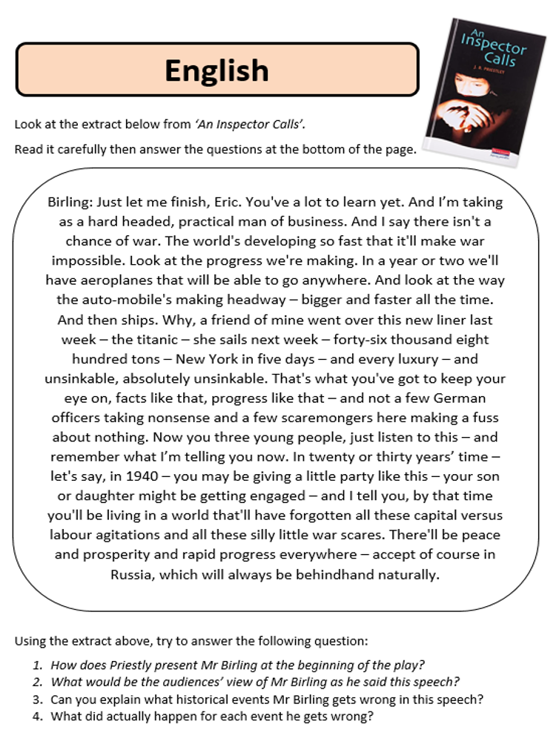

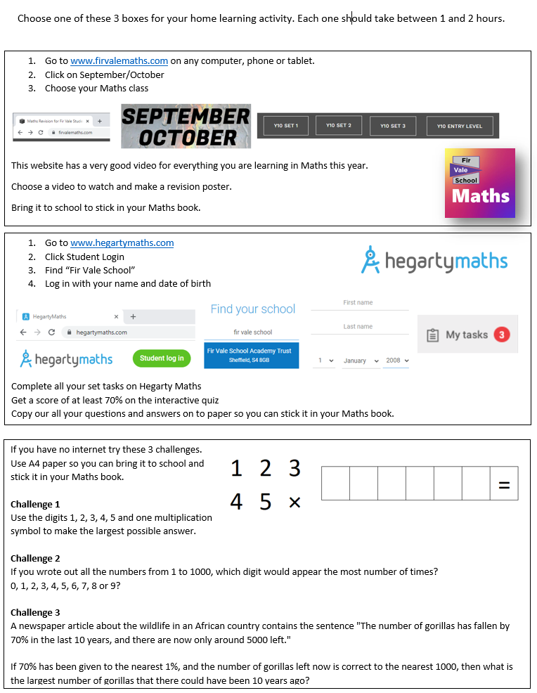
Maths
Options Subjects

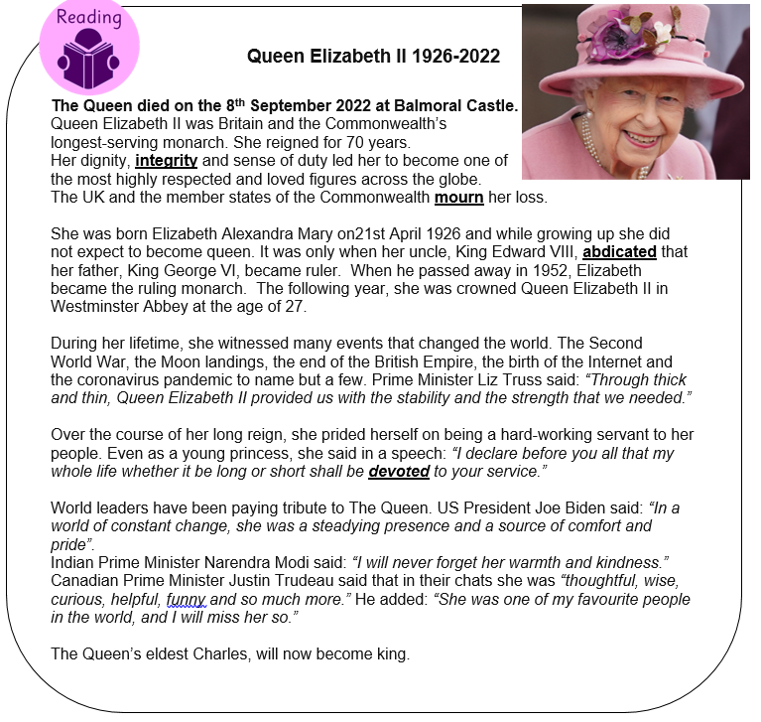
Your teachers have set you work in the option lesson last Wednesday or yesterday
Extension Activity
