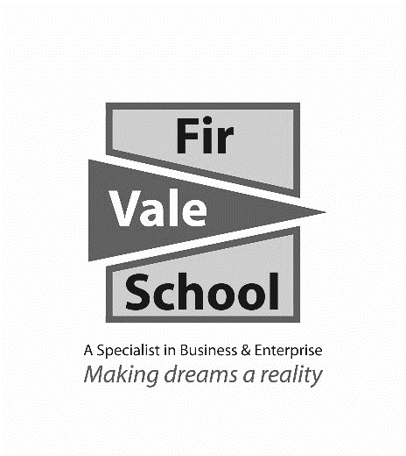

**Urdu**

**For more information speak to: Mr Salgado**

fsalgado@firvale.com

**Qualification:** GCSE Urdu

**Exam Board:** AQA

**Level of Achievement:** GCSE Grades 9 - 1



This course is divided up into **context** and purposes and the topic areas covered are useful and realistic in order to fully equip you with the necessary language skills to communicate in authentic life situation. The topics are:

**Theme 3: Current and future study and employment**

**Topic 1:** My studies

**Topic 2:** Life at school/college

**Topic 3:** Education post-16

**Topic 4:** Jobs, career choices and ambitions

**Theme 2: Local, national,**

**Topic 1:** Home, town, neighbourhood and region

**Topic 2:** Social issues

**Topic 3:** Global issues

**Topic 4:** Travel and Tourism

**Theme 1: Identity and Culture  
   
Topic 1:** Me, my family and Friends  
  **Topic 2:** Technology in everyday life

**Topic 3:** Free-time activities  
  
**Topic 4:** Customs and festivals in Urdu-speaking countries/   
communities

**How will I be assessed?**

You will be assessed in 4 different skills:

**Speaking exam (25%) Reading exam (25%) Listening exam (25%) Writing exam (25%)**

Speaking, Listening, Reading & Writing. All the assessments will take place in year 11. Speaking exams take place in April/May, before the rest of GCSEs start. Each skill area will account for 25% of your final grade.

**Future opportunities**

A Level Spanish leading to either a Spanish degree or a   
combined degree (many combinations are possible).

Directly linked to interpreter or translator jobs.   
Also beneficial for Journalist, Marketing, Sales,   
Tour Manager, and overseas work.

**What will I learn?**