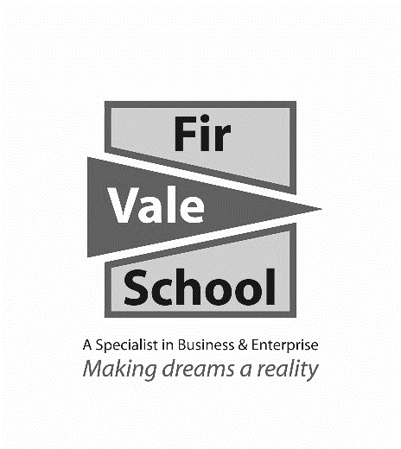

**Sport Studies**

**For more information speak to:** Mr Collins

**scollins@firvale.com**

**Qualification:** Cambridge National Certificate in Sport Studies

**Exam Board:** OCR

**Level of Achievement:** Level 1/2 Pass, Merit, Distinction



**Future opportunities**

**Assessment**

* 1 written exam paper (40%)
* Performance and Leadership practical assessment and assignments (40%)
* Sport and the Media assignments (20%)

**These marks then convert to a grade**

**All work is submitted using Microsoft Teams which can be easily accessed from home or on your mobile phone.**

* Vocational qualification in sport. E.g. NVQ, BTEC, OCR Cambridge Technical in Sport
* A Level Physical Education
* Apprenticeship in Sport
* Coaching, leadership & officiating qualifications
* Careers in the Sport industry, including, teacher, coach, personal trainer, sports therapist, physiotherapist, analyst & journalist

**You will study three units:**

1. **Contemporary Issues in Sport (Written exam)**

* Understand the issues which affect participation in sport
* Know about the role of sport in promoting values
* Understand the importance of hosting major sporting events
* Know about the role of national governing bodies in sport
* Learn about the different technology used in sport.

1. **Performance and Leadership in Sport activities (practical and written assessment)**

* Perform in an individual sport. E.g. Badminton
* Perform in a team sport. E.g. Football
* Organising and planning a sports activity session
* Leading a sports activity session
* Review own performance in planning and leading

1. **Sport and the Media (written assessment)**

* Know how sport is covered across the media
* Understand the positive effects that the media can have on sport
* Understand the negative effects that the media can have on sport

**How will I be assessed?**

**What will I learn?**