Snow closures
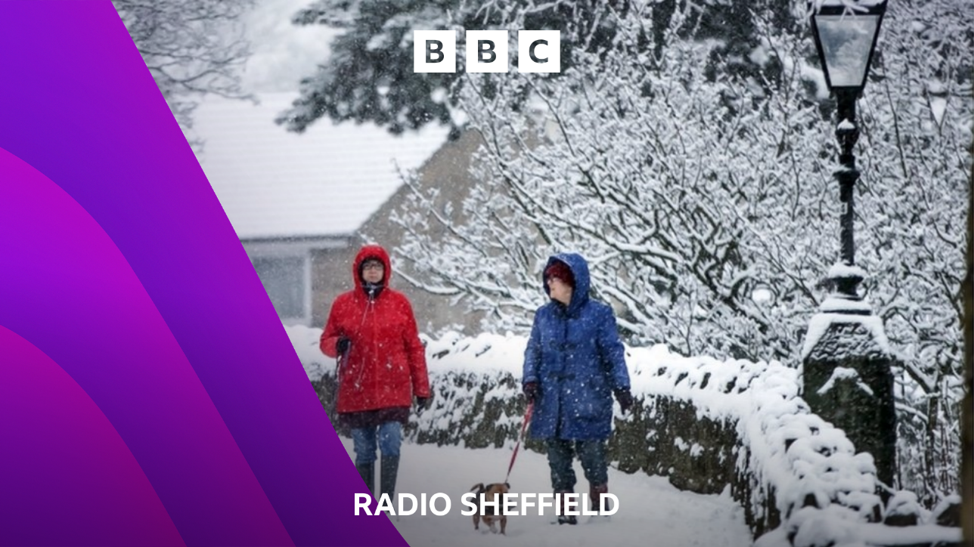

In the event of a school closure, please email radio.sheffield@bbc.co.uk from your school email address.
Alternatively call 0114 267 5440, quoting your DFE number (in the event of bad weather, the snow-watch line will be staffed from 6am or earlier).
We give school closure information out in Toby Foster at Breakfast and local information for South Yorkshire and North Derbyshire through the day.

