

**Photography**

**For more information speak to:** Miss Croft

**scroft@firvale.com**

**Qualification: GCSE Photography**

**Exam Board: AQA**

**Level of Achievement: Grades 9-1**  
GCSE Gra

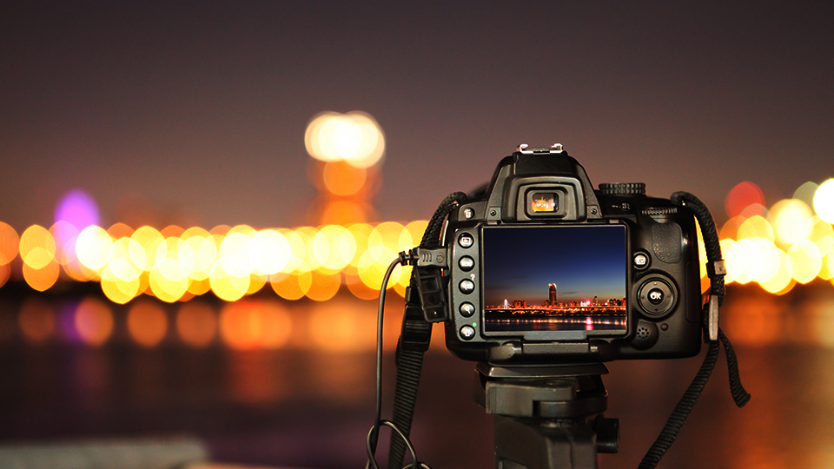

GCSE Photography is an important skill towards many KS5 creative subjects related to Creative Media. It will suit students who may be considering any career related to Media, Journalism, Reporting, Photography and many more creative areas, as well as those who enjoy expressing themselves creatively.

**Future opportunities**

Photography is marked in four areas: - Research – Refinement – Recording – Personalisation

These skills are shown through coursework projects produced over the two year course. The major coursework is weighted at 60% of the final grade (approximately 16 weeks in class time) with the externally set exam coursework being 40% of the final grade (12 weeks preparation time in class followed by a 10 hour exam)

Previous project work is a chance to show additional work and experimentation to support coursework.

**How will I be assessed?**

A variety of creative approaches to digital photography exploring colour and black and white imagery, portraiture, still life and abstract photography.

Technical aspects of the medium such as aperture, shutter speed, exposure, focus and depth of field will be explored, in addition to traditional aspects of image making such as composition, viewpoints and use of lighting. Creative use of digital technology will be developed to edit the images we have taken.

Whilst this is a creative subject it will also involve research into the work and techniques used by other photographers. The written element is integral to the subject and informs the creative practice that follows.

**What will I learn?**