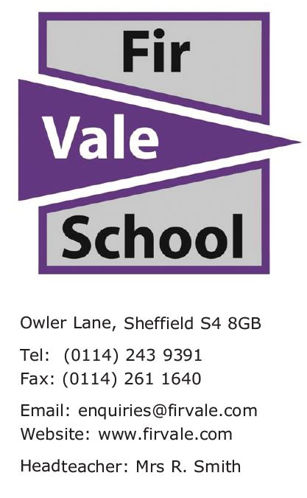
Our Ref: ACH/JLA/Y9Options2024
22 February 2024

Dear Parent/Carer
Year 9 Options Process
It is now time for your child to take the next step in their school career. Choosing the right GCSE and Vocational subjects for Key Stage 4 is one of the most important decisions a young person will make. The subjects chosen will affect the college and sixth form courses that can be studied, the apprenticeship route or even the University that a pupil chooses. Please make it a priority to attend the Options Evening on Thursday 29th February.
It is important that your child gets the support they need from both home and school.
Wednesday 28th February | Launch assembly for pupils on the Y9 Options process. Options information is available on the school website.  Visit the Our School tab, then select Our Curriculum.
Thursday 29th February  Parent Meeting | Year 9 Options Evening for pupils and parents  (3.30pm – 5pm)  This includes a presentation from the Headteacher and an opportunity to speak to teachers about what each subject involves.
Friday 22nd March | Final deadline - all options sheets handed in to Year 9 team.
There will be opportunities for your child to have a 1-1 conversation with staff
How can I support my child?
They will receive an information booklet in the coming days to help them make their choices. Talk to them about their future. Share with them your hopes about what future careers they might like to do.
Many thanks for your attendance to the event, we look forward to seeing you on Thursday 29th February at 3.30pm.

Please do not hesitate to contact Mr Ziarat (Head of Year 9) or myself if you have any further questions

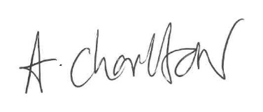
Yours faithfully
Ms A Charlton
Deputy Headteacher

