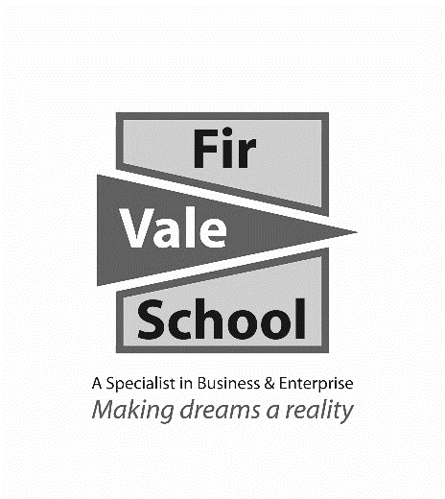

**Hospitality & Catering**

**For more information speak to:** Mr Swain

**jswain@firvale.com**

**Qualification:** Vocational Award in Hospitality and Catering

**Exam Board:** WJEC

**Level of Achievement:** Level 1/2 Pass, Merit, Distinction.

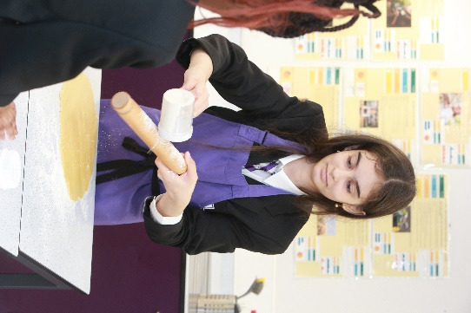

This course can lead onto Level 3 study in food,   
catering and hospitality.

It can also lead into apprenticeships and careers in the   
food and hospitality industry.

**Future opportunities**

Classroom based coursework and practical exam 60% of final grade.

Written exam in June of Y11 – 40% 1½ hours.

**How will I be assessed?**

If you like cooking or are considering a career in the hospitality industry then this is the qualification for you. We have introduced a level 1 and 2 course in Hospitality and Catering. Learners will develop the skills and knowledge to prepare high quality food within a commercial catering setting.

The course comprises of two units:  
**Unit 1:** A study of the Hospitality and Catering Industry looking at job roles, responsibilities and different industry sectors like hotels, holiday parks and restaurants. **Unit 1** is assessed by examination.

**Unit 2:**  Designing and making dishes that could be served at a restaurant. It covers nutrition, food preparation and planning. **Unit 2** is assessed in school. You will have to make a   
two-course meal.

**What will I learn?**