GCSE Geography
How will I be assessed?
You have three exams at the end of Year 11.
- Paper 1: 1 hour and 30 minutes and 88 marks
- Paper 2: 1 hour and 30 minutes and 88 marks
- Paper 3: 1 hour and 15 minutes and 76 marks
- All the marks will be combined and students will receive 1 grade.

Exam Specification
AQA Geography 8035
More information can be found here https://www.aqa.org.uk/subjects/geography/gcse/geography-8035/introduction

Topic | Sub-topics
Paper 1  The challenge of natural hazards | Natural Hazards  Climate Change
The living world | Tropical Rainforests  Cold Environments
Physical landscapes in the UK | Coasts  Rivers
Paper 2  Urban issues and challenges | Urbanisation  Urban Growth LICs/NEEs  Urban Change HICs  Urban Sustainability
The changing economic world | Economic Development  Change in LICs/NEEs  Changes in HICs
The challenge of resource management | Global Patterns  Resource Insecurity  Changing Demands in the UK  Choice: Food, Water or Energy
Paper 3 Pre Release | Any compulsory topic.
P3. Fieldwork | 2 fieldwork trips one physical and 1 human.

How can I revise?
Each student will be given key word sheets and revision sheets for each topic as the topics are being taught.
Some of the best revision guides for geography are below.

Any questions or for more information speak to:
Miss Holland
jholland@firvale.com

Mr Highfield
Phighfield@firvale.com

Revision Guides
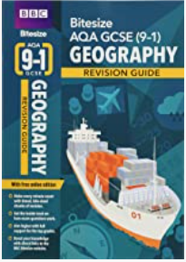  New Grade 9-1 GCSE Geography AQA BBC Bitesize Revision Guide | 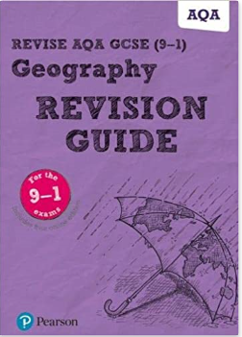  New Grade 9-1 GCSE Geography AQA Pearson Revision Guide

