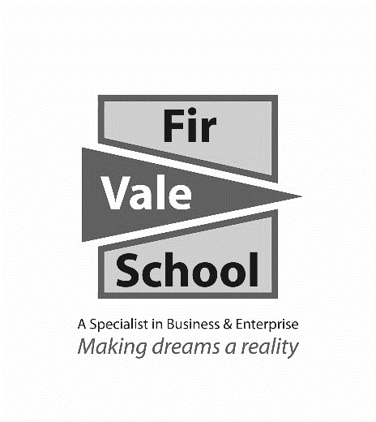

**English Literature**

**For more information speak to:** Mr Yarsley

**myarsley@firvale.com**

**Qualification:** GCSE English Literature

**Exam Board:** AQA

**Level of Achievement:** GCSE Grades 9 - 1

Two final examinations at the end of Y11

* **Paper 1:** Romeo and Juliet and A Christmas Carol.
* **Paper 2:** An Inspector Calls, AQA Anthology Poetry (Power and Conflict) and Unseen poetry.

Paper 1 is 1 hour and 45 minutes and Paper 2 is 2 hours 15 minutes. Students are awarded a grade based on the results of both papers combined.

You will study 4 key texts across 3 different genres and multiple time periods:

|  |  |  |
| --- | --- | --- |
| **Novel:** | **Plays:** | **Poems:** |
| ‘A Christmas Carol’ by Charles Dickens. Students will read the novel to gain a full understanding of both key characters and themes of the texts. | ‘Romeo and Juliet’ by William Shakespeare and ‘An Inspector Calls’ by J.B Priestly. Students study both plays to gain a full understanding of characters, themes and context. | * Students cover 15 poems from the AQA ‘Power and Conflict’ as well as learning key skills needed to examine and comment on unseen poetry. |

Pupils will be given revision guides for all the key texts in this course. The topics they need to revise are highlighted on the contents page at the front of the revision guide. The guides will cover all the key characters and their link to the main themes of each text. The guides will also offer detail on the historical and social context of each of the key texts, as well as exam practise and guidance.

**How can I revise?**

**How will I be assessed?**

**What will I learn?**