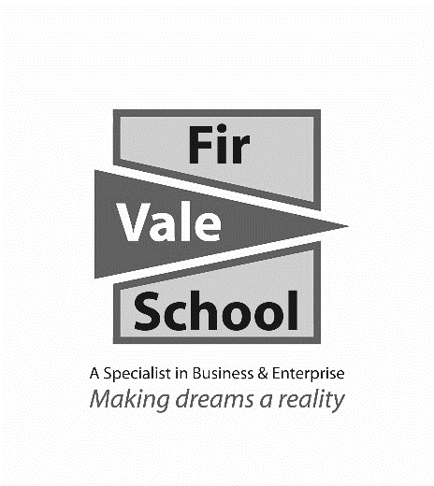

**English Language**

**For more information speak to:** Mr Yarsley

**myarsley@firvale.com**

**Qualification:** GCSE English Language

**Exam Board:** AQA

**Level of Achievement:** GCSE Grades 9 - 1

You will study key reading and writing skills in both fiction and non-fiction texts:

|  |  |
| --- | --- |
| **Fiction:** | **Non-fiction:** |
| * Responding to a single piece of fiction, through 4 comprehension style questions. * Producing a piece of narrative or descriptive writing based on an image provided. | * Responding to 2 linked pieces of non-fiction, through 4 comprehension style questions, including comparing the texts. * Producing a piece of non-fiction writing for a specific audience and purpose. |

Pupils will be given a revision guide for this course. The topics they need to revise are highlighted on the contents page at the front of the revision guide. The guide will cover all possible questions that will be asked across both papers, such as how to study how a text is structured for effect and how to compare 2 texts for similarities and differences.

**How can I revise?**

Two final examinations at the end of Y11

* **Fiction:** Explorations in creative writing.
* **Non-fiction** – Writer’s viewpoints and perspectives.

Each examination is 1 hour and 45 minutes long and is worth 80 marks. Pupils will receive 1 grade for their results combined.

**How will I be assessed?**

**What will I learn?**