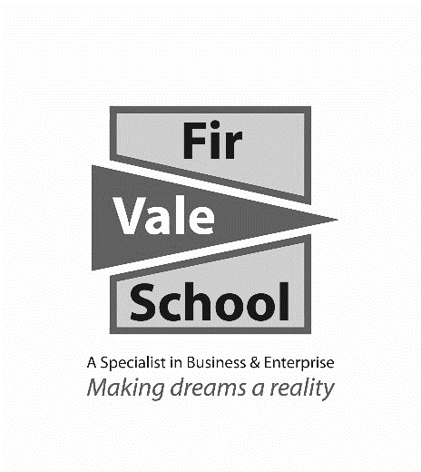

**Dance – Level 2**

**For more information speak to:** Miss Emptage

**cemptage@firvale.com**

**Qualification**: BTEC Tech Award Performing Arts - Dance

**Exam Board:** Pearson

**Level of Achievement:** Level 1-2 Pass, Merit, Distinction

(Equivalent to GCSE grades 1-9)



**How will I be assessed?**

The course is assessed via coursework. There is no final examination. You will complete 3 pieces of coursework over Y10 and Y11.

**Component 1 – Exploring the Performing Arts:** In this unit you will investigate how a professional dance performance is created. You will analyse a professional dance routine. You will learn some of the skills, techniques and approaches used by professional dancers and choreographers to create performance work.

**Component 2 – Developing Skills and Techniques in the Performing Arts:** In this unit you will learn a new professional dance routine. You will take part in workshops where you will develop your technical, practical and interpretative skills through the rehearsal and performance process. Be ready to learn dances from a variety of styles and develop and expand your professional repertoire.

**Component 3 – Responding to a Brief:**  You will be given a creative brief from the exam board and you will be required to create a dance to meet that brief. You will be given a stimulus and will need to use this stimulus to create your own dance. You will work as part of a group to develop your ideas before performing this dance to an audience.

The BTEC Dance course is designed for anyone with an interest and love for dance performance. The course will push and motivate you to become a well-trained technically able performer. The course will prepare you to progress within the performing arts industry and for further education. The course requires you to plan, develop and perform.

You will build up your skills and confidence and demonstrate your knowledge through both practical performances and coursework. You will have the opportunity to attend professional productions and develop your knowledge further throughout the duration of the course.

**Compulsory – You will need to take part in practical dance lessons. You will be expected to learn a variety of dance styles.**

**What will I learn?**

Professional Dancer, Dance Teacher, Dance Therapist,   
Dance Journalist, Choreographer, Creative Director.

**Future opportunities**