

**Citizenship**

**For more information speak to:** Miss Cassy

**jcassy@firvale.com**

**Qualification:** GCSE Citizenship

**Exam Board:** Edexcel

**Level of Achievement:** GCSE Grades 9 - 1

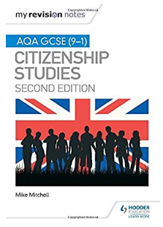

**How will I be assessed?**

* Two final examinations at the end of Y11
* Each examination is 1 hour and 45 minutes long
* Campaigning and pressure groups
* Government and voting
* Diversity and community
* Rights and responsibilities
* The law and criminal justice
* Media
* Global Issues

**What will I learn?**

By using your revision guide

You tube video clips

Using the mind-maps we make in class

**How can I revise?**

**What will I learn?**