

**Child Development**

**For more information speak to: Ms Newton**

*rnewton@firvale.com*

**Qualification:** Cambridge National Level 1/2 in Child Development

**Exam Board:** OCR

**Level of Achievement:** Level 1/2 Pass/Merit or Distinction

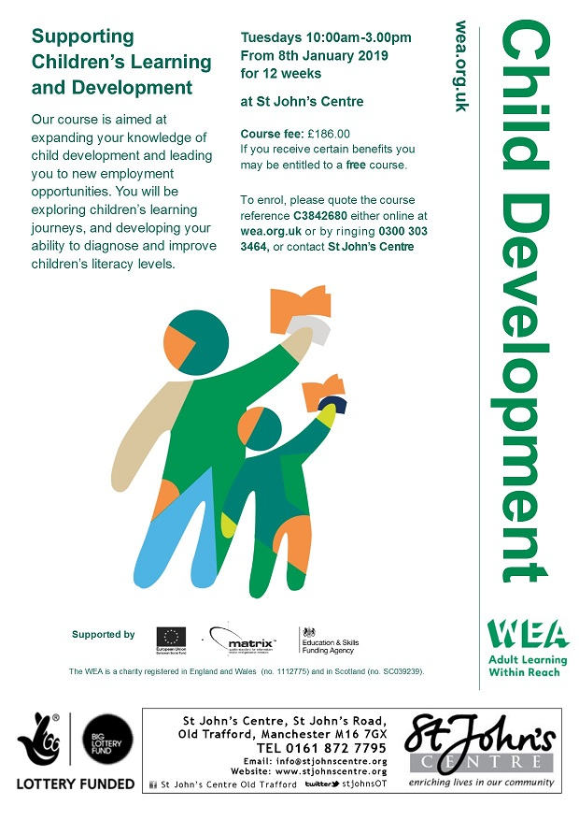

This course provides an excellent foundation for working with children in   
healthcare or nursery settings. Most colleges offer Level 3 courses in   
child care which are equivalent to ‘A’ levels and will allow you to access   
courses at university.

This course also provides the opportunity to gain an NFCE level 1 award   
or certificate in caring for children so all abilities are catered for in this   
subject.

**Future opportunities**

**Unit R057** - This unit is assessed by an exam (1 hour 15 minutes) which you will sit in Y11. (50%)

**Unit R058** – This unit is assessed by assignments completed in class. (25%)

**Unit R059** - The development of children from birth to 5 years is assessed by assignments completed in class. (25%)

**How will I be assessed?**

In this course you will learn about:

* **Unit R057 Health and well-being for a child** – Understanding reproduction, antenatal and postnatal care and parenthood.
* **Unit R058 Creating a safe environment and understanding the nutritional needs of children from birth to 5 years** – Key factors when choosing equipment and understanding nutrition in children.
* **Unit R059 Understand the development of children from birth to 5 years** – Understanding physical and social development in children and investigate the benefits of play.

**What will I learn?**