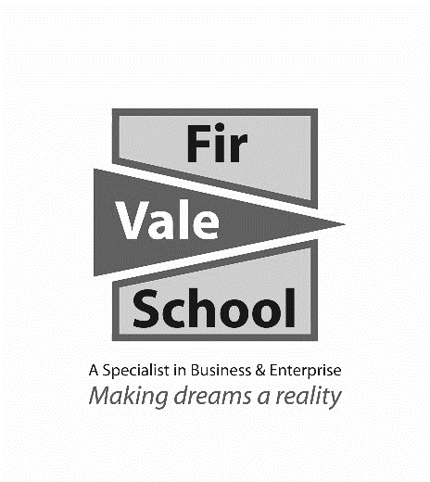

**Art**

**For more information speak to:** Miss Croft

**scroft@firvale.com**

**Qualification:** GCSE Fine Art

**Exam Board:** AQA

**Level of Achievement:** GCSE Grades 9 - 1

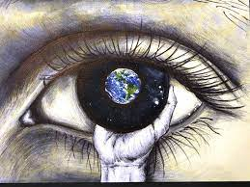

**Future opportunities**

GCSE Art is an important skill towards any KS5 creative subjects related to Art and Design. It will suit students who may be considering any career related to Art and Design or working creatively with young people or adults, as well as those who   
enjoy expressing themselves creatively.

GCSE Art is transferable to a wide variety of courses and   
employment opportunities such as social work, law, the police, journalism and many more.

Art is marked in four areas: - Research – Refinement – Recording – Personalisation

These skills are shown through coursework projects produced over the two year course. The major coursework is weighted at 60% of the final grade (approximately 16 weeks in class time) with the externally set exam coursework being 40% of the final grade (12 weeks preparation time in class followed by a 10 hour exam)

Student sketchbook is a chance to show additional work and experimentation to support coursework.

**How will I be assessed?**

Coursework will consist of 2 main practical projects demonstrating the use of drawing, painting, printing, photography digital work and 3D work. This work will be supported by the study of a range of different artists, designers and styles of work. Projects will be based around themes such as identity, Shape and Form, and Abstraction and allow personal responses and approaches to suit the strengths of individual students.

As well as developing practical skills and the imaginative use of materials, this subject will seek to enhance creative thinking, independent work and problem solving capabilities, whilst gaining the ability to respond to the ideas of other artists and designers.

**What will I learn?**