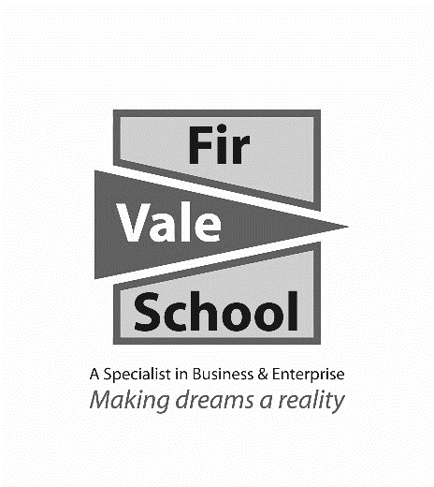

**Arabic**

**For more information speak to:** Mr Salgado

**fsalgado@firvale.com**

**Qualification:** GCSE Arabic

**Exam Board:** Edexcel

**Level of Achievement:** GCSE Grades 9 - 1

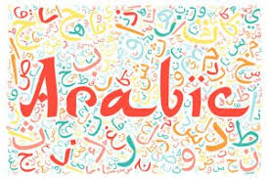

You will be assessed in 4 different skills:  
**Speaking exam (25%) Reading exam (25%) Listening exam (25%) Writing exam (25%)**

Speaking, Listening, Reading & Writing. All the assessments will take place in year 11. Speaking exams take place in April/May, before the rest of GCSEs start. Each skill area will account for 25% of your final grade.

**How will I be assessed?**

You will learn the following topics and language aspects in the context of Britain and Arabic speaking countries.

**Theme 1: Identity and culture Theme 3: School Theme 5: International and**- Who am I? - What school is like **global dimensions**  
- Daily life - School activities - Bringing the world together  
- Cultural Theme - Environmental issues

**Theme 2: Local area, holiday Theme 4: Future aspirations   
and travel study and work**  
- Holidays - Using language beyond the classroom  
- Travel and Tourism attractions - Ambitions  
- Town, regions and country - Work

A Level Arabic leading to either an Arabic degree or a combined degree   
(many combinations are possible).

Directly linked – interpreter / translator jobs where it would be helpful:

Journalist, Diplomat, Marketing, Sales, Tour Manager.

**Future opportunities**

**What will I learn?**