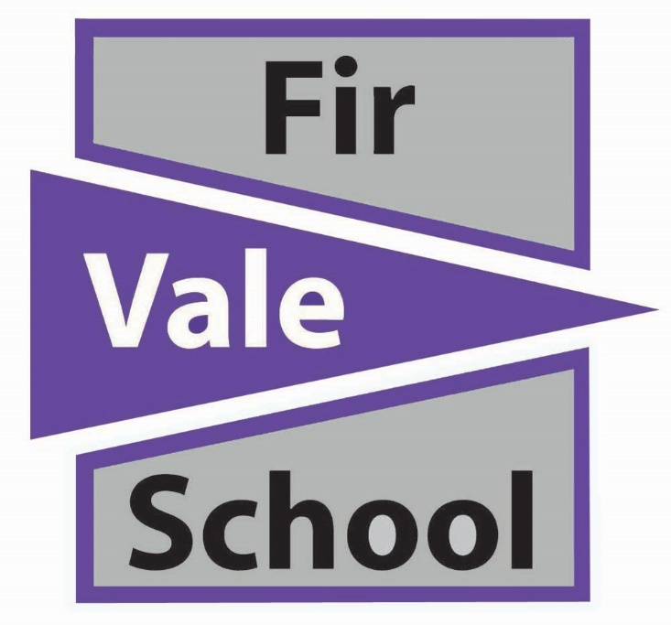

Admissions Policy
Years 7 - 11

Review Date | February 2023
Approved | Governors Meeting
Ratified | Full Governors
To be Reviewed | September 2024
Policy Lead: | E Montgomery

Catchment area

All applicants must live in the catchment area as defined jointly by the Academy and the Secretary of State for Education, and agreed by Sheffield City Council. This requirement means that, on the date of application the child’s permanent address and that of his/her legal guardian(s) must be within the catchment area. Any falsification of information on this point or the use of relative’s addresses in the catchment area will immediately invalidate any application at whatever stage of the process such falsification is discovered.

Admission arrangements approved by Secretary of State

1. The admission arrangements for Fir Vale Academy Trust for the year 2022-23 and, subject to any changes approved by the Secretary of State, for subsequent years are:

a) The academy has an agreed admission number of 210 students in Years 7-11.
b) The Academy may set a higher admission number than its published admission for any specific year. Before setting an admission number higher than its agreed admission number, the Academy will consult Sheffield LA, other relevant admission authorities and the governing body. Students will not be admitted above the published admission number unless exceptional circumstances apply and such circumstances shall be reported to the Secretary of State;

c) The Academy will exercise no selection policy on the basis of academic ability or aptitude.

2. Fir Vale Academy Trust will use the following timetable for applications each year (exact dates within months may vary from year to year);

a) September: The Academy will publish on its website information about the arrangements for admission the following September, including over subscription criteria. This will include details of open evenings and other opportunities for prospective students and their parents to visit the Academy. Fir Vale Academy will also provide information to the LA for inclusion in the composite prospectus, as required;

b) September: The Academy will hold its open evening for Year 5/6.

c) December to February: Applications are considered in consultation with Sheffield LA and any other admissions authorities in relation to general strategic planning for admissions;

d) March: Offers of places notified in writing to parents;

e) June: Independent appeals.

This timetable seeks to harmonise arrangements with those of Sheffield LA and as developed within Sheffield. In this way, it is intended to secure a coordinated approach to admission for parents and students.

Consideration of applications

3. Fir Vale Academy Trust will consider all applications for places. Where fewer than 210 applications are received, the Academy will offer places to all those who have applied.
4. Notwithstanding clause 3 above, Fir Vale Academy Trust may refuse admission to particular applicants in cases where fewer than the published admission number have applied. Academies may refuse admission to students (other than in the normal year of entry) in the specific and limited circumstances described in the School Admissions Code. In all the circumstances described in this paragraph, however, the Secretary of State may direct Fir Vale Academy Trust to admit such a student and that direction shall be binding.

Procedures where the Academy is oversubscribed

5. Where the number of applications for admission is greater that the published admissions number, applications will be considered against the criteria set out below. The criteria will be applied in the order in which they are set out:

a) “Looked After” children or Previously “Looked After” children;

b) Those students permanently resident in the Academy catchment area who express a preference;

c) Those students whose siblings (including step children, half-brothers/sisters and foster children living in the same address) will already be on the Academy roll in the September of their proposed entry;

d) Those students with social and/or medical reasons for attending the Academy, which in the latter circumstances, are substantiated by the Sheffield Authority’s medical advisers and accepted by the Academy;

e) Those students whose home front entrance door is closest to the Academy front entrance.

6. Notwithstanding the provisions of paragraphs a-e, the Secretary of State may direct Fir Vale Academy to admit a named student on application from a LA. The Secretary of State shall in such circumstances consult with Fir Vale Academy before making such a direction and have regard to its comments.

Operation of waiting lists

7. Where-in any year Fir Vale Academy receives more applications for places than there are places available, a waiting list will operate. This will be maintained by the LA and it will be open to any parent to ask for his or her child’s name to be placed on the waiting list.

8. A child’s position on the waiting list will be determined solely in accordance with the oversubscription criteria set out by the LA. Where places become vacant they will be allocated to children on the waiting list in accordance with the oversubscription criteria.

9. Children applying to go into other year groups will be admitted if there are places available. Parents/Carers who have been refused a place in other year groups also have a statutory right of appeal.

Arrangements for the admissions appeal panel

10. Parents/Carers will have the right of appeal to an independent Admissions Appeal Panel if they are dissatisfied with an admission decision of the LA or Fir Vale Academy. The panel set up by Sheffield Local Authority in accordance with the relevant Admission Appeal Code for such appeals will hear all the cases submitted in writing by parents/carers to the LA. Any such appeal will be processed in accordance with the requirements of the same code.

