CANDIDATE EXAM HANDBOOK
2025/26

This handbook is reviewed and updated annually
Produced/reviewed by
Date of next review

Contents
Introduction 4
Purpose of this handbook 4
Malpractice 4
Personal data 5
Copyright 5
Coursework assessments/non-examination assessments 5
Written timetabled exams 6
Contingency session - Summer 2026 6
On-screen tests 6
What to do if you identify you have two or more exam papers timetabled at the same time (a timetable clash) 7
Where you will take your exams 7
What time your exams will start and finish 7
Supervision during your exams 7
Exam room conditions 7
Where you will sit in the exam room 8
How your identity is confirmed in the exam room 8
What equipment you need to bring to your exams 8
Using calculators 8
What you must not bring into the exam room 8
Food and drink in exam rooms 9
What you should wear for your exams 9
Where your personal belongings will be stored during your exam 9
What to do if you arrive late for your exam 9
What to do if you are unwell on the day of your exam 9
What happens if you have an unauthorised absence from your exam 9
What happens in the event of an emergency in the exam room 9
Candidates with access arrangements/reasonable adjustments 9
Results 10
Post-results services 10
Certificates 10
Internal appeals procedure 10
Complaints policy 10
APPENDIX 1 11
JCQ Information for candidates - coursework 11
APPENDIX 2 12
JCQ Information for candidates – non-examination assessments 12
APPENDIX 3 13
JCQ Information for candidates – on-screen tests 13
APPENDIX 4 14
JCQ Information for candidates – written exams 14
APPENDIX 5 15
JCQ Information for candidates – social media 15
APPENDIX 6 16
JCQ Information for candidates - AI (Artificial Intelligence and assessments) 16
APPENDIX 7 17
JCQ Unauthorised items poster 17
APPENDIX 8 18
JCQ Warning to candidates poster 18
APPENDIX 9 19
JCQ AI poster for students 19
CANDIDATE CONFIRMATION 20

Introduction
Fir Vale Academy is committed to ensuring that candidates are fully briefed on the examination and assessment process in place in the centre and are made aware of the required JCQ/awarding body instructions and information for candidates.

Purpose of this handbook
Overtype here the purpose of this handbook in your centre.
Examples
- To support/complement candidate briefings/assemblies
- To inform candidates about malpractice in examinations/assessments
- To inform candidates about the use of their personal data and copyright
- To ensure candidates are provided with all relevant information about their exams and assessments in advance of any exams/assessments being taken
- To ensure copies of relevant JCQ information for candidates documents and exam room posters are provided in advance of any exams/assessments being taken
- To answer questions candidates may have etc.
- To inform candidates of/signpost candidates (and where relevant parents/carers) to any exams-related policies/procedures they need to be made aware of

Malpractice
The (JCQ) are the body responsible for the rules and regulations for examinations and assessments.
JCQ in order to maintain security and integrity have put in place strict regulations and these must be maintained at all times.
Malpractice means any act or practice which is a breach of the rules and regulations that apply to the exam or assessment being taken.
Any alleged, suspected or actual incidents of malpractice will be investigated and reported to the relevant awarding body/bodies
JCQ provides information regarding what malpractice is:
- Introduction of unauthorised material into the examination room
- Breaches of examination conditions
- Exchanging, obtaining, receiving, or passing on information which could be examination related (or the attempt to)
- Offences relating to the content of candidates’ work
- Undermining the integrity of examinations/assessments

Other forms of malpractice are listed below but can also be found in the JCQ information for Candidates booklets. Website links for these booklets can be found in the Appendices at the back of this handbook.
Candidates should know that the following would be classed as malpractice:
• Copying or allowing work to be copied – e.g. posting written work on social networking sites prior to an examination/assessment;
• Collusion: allowing others to help produce your work or helping others with theirs;
• Asking others about what questions your exam will include (even if no one tells you);
• Having or sharing details about exam questions before the exam - whether you think these are real or fake; or
• Not telling exam boards or your school/college about exam information being shared.

Things not to do on social media:
• Buy/ask for/share exam content
• Pass on rumours of what’s in exams
• Share your work
• Work with others so that your coursework is not your own independent work. This also includes Non- Examination Assessments.

Research and using references
Where computer-generated content has been used (such as an AI Chatbot), your reference must show the name of the AI tool used and should show the date the content was generated. For example: ChatGPT 3.5 (https://openai.com/blog/chatgpt/), 25/01/2026.
You should also reference the sources used by the AI tool in generating the content.
You must retain a copy of the question(s) and computer-generated content for reference and authentication purposes in a non-editable format (such as a screenshot) and provide a brief explanation of how you used it. This must be submitted with your work for final assessment so that your teacher can review the work, the AI-generated content and how it has been used.
If you copy the words, ideas or outputs of others and do not show your sources in references and a bibliography, this will be considered as cheating.
Plagiarism
Plagiarism involves taking someone else’s words, thoughts, ideas or outputs and trying to pass them off as your own. It could also include AI-produced material. Plagiarism is a form of cheating which is taken very seriously.

Personal data
In order to register candidates for examinations, awarding bodies must be provided with a certain amount of personal information in order to identify each candidate for each specific exam.
How this information is collected and used by the awarding body can be found in the JCQ Information for candidates- Privacy Notice.

Examples of when Personal Data and information are provided to and used by the awarding body:
- Any person involved in completing examinations/assessments where malpractice is suspected, or alleged, personal data about them will be provided to the awarding body (or bodies) whose examinations/assessments are involved. Personal data about them may also be shared with other awarding bodies, the qualifications regulator or professional bodies...
- The centre will provide relevant personal data including name, date of birth, gender to the awarding bodies for the purpose of examining and awarding qualifications.
- Materials which are submitted by candidates for assessment may include any form of written work, audio and visual materials, computer programs and data (“Student Materials”). Awarding bodies may use the Student Materials to evaluate candidates’ performance in the relevant assessment. They may also use the Student Materials for other purposes as outlined in their privacy policies and in accordance with their terms. Candidates should be directed to the relevant awarding body’s privacy notice if they require further information about how their Student Materials may be used by the awarding body.

Copyright
Copyright is a set of rules that protect the things people create. It gives the creator control who can use their work and how it can be used.
Any form of work that is created by a candidate that is submitted to an awarding body for assessment (also known as Assessment Materials) belongs to the candidate.
By submitting work, a candidate is granting the awarding body authority to use their assessment materials (Assessment Licence)
If a candidate wishes to terminate the awarding body’s rights for anything other than assessing the candidates work, the awarding body must be notified by the centre (Fir Vale Academy) and it is at the discretion of the awarding body whether or not to terminate such rights.

Coursework assessments/non-examination assessments
Coursework assessments/ non examination assessments (NEA) are forms of assessment that are done without the use of written exams and are completed over a series of weeks or months.
Information relating to the rules and regulations around coursework assessments/ non-examination assessments can be found in various documents that are listed in the appendices at the back of this booklet. These documents include the following JCQ Information for Candidates; coursework, non-examination assessments, on screen tests, privacy notice, social media and written assessments. These documents can also be found at the following website www.jcq.org.uk/exams-office/information-for-candidates-documents/. It is important that the candidate takes time to read these documents.
Candidates will be informed by their subject teacher when and how these assessments will take place during the academic year.
Deadlines for these types of assessments are set by the awarding bodies and the deadlines must be met. Failure to meet these deadlines can result in that assessment not being marked and graded which would affect the overall grade for the candidate.
For these types of assessments, they are usually first marked by the subject teacher and the marking is then checked by a moderator appointed by the awarding body. The moderator will check carefully how the work has been marked and will adjust any marks or grades accordingly as required.
After the teacher has marked the candidate’s work, it is important that the candidate is made aware of the marks given by the teacher for the assessment. This must be done before the marks are submitted to the awarding body. If the candidate feels their work has been marked incorrectly, they have the right to appeal the mark internally within the school. The internal appeals procedure can be found on the school website.
It is important that candidates are aware of the use of AI in assessments. Candidates should be aware of the poster that is on Appendix 9 at the back of this booklet.

Written timetabled exams
Before sitting any written exams, candidates will be provided with a personal statement of entry. This shows which examinations the candidate will be sitting along with when the exams will take place. It is important that candidates check all information on this sheet is correct. This includes personal information and the exam entries. If any information is incorrect on this sheet, candidates should speak with their subject teacher or the examinations manager.
Candidates will also be provided with a general exam timetable. This will be placed on the exam board (near the T junction) and will show all the examinations that will be taking place in the summer. Candidates will also be provided with an individual timetable, which will show specific examinations for that candidate and the rooms that these exams will take place in.
Seating plans will be available outside each room, which is being used for written examinations. These will show exactly where each candidate must sit for each examination. If candidates do not sit in the correct seat shown on the seating plans, it may result in loss of marks or disqualification.
Further information including the rules and regulations for examinations please use the links on Appendix 4 and 5. JCQ Information for Candidates- Written exam & JCQ Information for Candidates- Social Media.

The 2 JCQ exam room posters will also be at the entrance to each exam room used by the centre. Students must be aware of the information included on both these posters on entering the exam room. Examples of the exam room posters can be found in Appendix 7 and 8. Failure to follow the rules listed in these posters will result in malpractice.

Contingency session - Summer 2026
Each examination series will include a contingency session(s). These are either morning, afternoons or full days where no examinations are scheduled to take place. If a national emergency is to take place during the examination series that prevents exams from being undertaken by candidates on the scheduled date, the examination will be moved to the contingency session.
For summer 2026 examination series, there is one contingency session:
24th June 2025- Full day
All students must be available up to and including the 24th June 2025.

What to do if you identify you have two or more exam papers timetabled at the same time (a timetable clash)
A timetable clash is the when two or more examinations are due to be taken at the same time and on the same date.
If candidates do have any timetable clashes, letters will be sent out to students and parents informing them that they have timetable clashes. Candidates will be made aware of their timetable clashes when they are given their individual timetables. Candidates who have any questions about their timetable clashes should speak to the examinations team.
In order to resolve timetable clashes, candidates may be required to sit examinations back-to-back. Candidates will be allowed a maximum of a 20-minute break within the exam room between examinations but they must remain under exam conditions.
Candidates who have 2 or more examinations in one session and the examinations total length is longer than 3 hours can ask to move one of the examination papers to an earlier or later session. If the candidate wishes to do this, they must remain under centre supervision by a member of staff with no access to electronic devices or other candidates until all exams have been completed by the student on that day. Centre staff will not be able to coach students during this period.
In order to resolve timetable clashes that involve candidates who are undertaking 2 or more exams in an afternoon session or the total exam time for the day exceeds 5 and half hours may require one of the examinations to be completed the following morning (including Saturdays). Students and parents will be invited in for a meeting with centre staff to discuss the resolution of this clash. At all times the integrity of the exams is key. Candidates will not be allowed access to any electronic devices including mobile phones, televisions, and computers and will not be allowed to interact with any other candidates until the completion exam.

Where you will take your exams
For the majority of candidates at the centre the written examinations will take place in either the sports hall or the enterprise centre. When needed, other offices or classrooms will be used around the centre as and when required.
Candidates will be made aware of the rooms they will be taking their examinations in through their individual timetables. If candidates are still unsure as of the room they will be taking their examinations in, please contact the examination team.

What time your exams will start and finish
During the examination season there are two sessions throughout the day when exams will take place; the morning and afternoon.
Morning exams will begin at 9.00am.
Afternoon exams will begin at 1.30pm
Candidates must remain under centre supervision until 1 hour after the published start time or until the publish end time.
E.g. if the examination only lasts 30 minutes in a morning session, the candidates must remain under centre supervision until 9.30am.
If candidates leave the room before the published end time or before one hour after the published start time and are not under centre supervision, the candidate will face malpractice proceeding which can result in loss of mark. disqualified from the examination and disqualification from any future examinations.

Supervision during your exams
Supervision of candidates during examinations will be done by a team of invigilators who have undertaken training and assessment in order to supervise candidates during their examinations.
The majority of the team of invigilators will have been present during one or more of the trial examinations that have taken place during the academic year.
Invigilators must follow a strict set of rules and regulations that are created by JCQ and the awarding bodies in order to keep the security and integrity of each examination.
Subject teachers may not be present in the hall during the duration of the exam.
SLT may only be present in the exam hall at the start of the exam to identify candidates and instil discipline, check the correct question paper has been issued and commence the exam.
SLT may only re-enter the examination room if there are any issue which cannot be resolved by an invigilator e.g. disruption by a candidate.
The SLT member who enters the examination hall will be appointed by the Head of Centre.

Exam room conditions
There will be a booster session before each exam. From there candidates will be directed to their exam room.
JCQ exam posters will be displayed on the door as the candidates enter the exam room. Examples of these posters can be found at the back of this booklet in Appendix 7 and Appendix 8 with links to where they can be found online.
Candidates will be greeted at the door by an invigilator or a member of SLT, who will inform them that they are now under exam conditions as they walk through the door. Candidates as they enter the room will be asked to turn off all electrical equipment and remove all paper from their pockets. Candidates will be informed that there is now no communicating or disturbing of other candidates until they exit the exam room. Any candidates who attempt to communicate or disturb any candidates once they have entered the exam room must be reported to the relevant awarding body.
As the candidates begin to be seated, they will be informed they must not open the exam paper until they are told to do so. They will be informed they can complete the front cover with information it requires. Candidates must not open the exam paper until the examination begins, if they do they must be reported the relevant awarding body.
The projector at the front of the hall will show the date, subject title, awarding body, start and finishing times of each exam taking place at that time.
Before the start of the examination the Examinations Manager/ Invigilator will make the exam announcement stating the rules of the exam and explaining what is required of each student.
It is important that candidates do not open the question paper until they are instructed to do so. If the paper is opened before the instruction is given, it may result in loss of marks of disqualification.
It is important to note that candidates must be aware that any instructions given by the invigilator must be followed immediately. Failure to do so may result in loss of marks or disqualification.
Candidates may only leave their seat when instructed to do so. When leaving the examination room candidates must do so quietly without disturbing any candidates who may be still be sitting their examinations. Candidates must remain in silence until they leave the examination room and are clearly away from the exam room entrance. Any attempted communication while in the exam room will be reported to the exam board.

Where you will sit in the exam room
The exam room will be set out in rows and columns. The rows will be listed 1 to 17 and the columns A to M. The letter and numbers of each row and column will be clearly visible on the walls, adjacent to each row and column.
All desks will be facing towards the projector/screen or whiteboard. Seats and exam tables must not be moved unless instructed to do so by the invigilator.
For the majority of examinations, candidates will be allocated a seat for the duration of the examination season. It is very important that candidates check the seating plans for each exam as candidates must sit in the seat they have listed on the seating plan.
Seating plans can be found on exam board (T-junction), sports hall walland on the entrance to the exam room.
Each desk will also have a sticker on which lists the name of the candidate, exam number, form group and centre number.
Candidates must sit in their allocated seat. If candidates do not sit in their allocated seat, this will be classed as malpractice and reported to the exam board. A candidate may only move seats if instructed to do so by an invigilator.

How your identity is confirmed in the exam room
Each student will be allocated a desk and this will have the personal details of the candidate. This includes name of the candidate, exam number, form group and centre number.
Before each exam a member of SLT or head of year will be present on entry to check the candidates that are entering the exam room are correct.
Invigilators will also be provided with photos all students who should be present in the exam room.

What equipment you need to bring to your exams
Candidates will be asked to bring a black pen to their examinations. Equipment will be provided by the invigilators at the start of each exam according to what is listed on the front of the question paper.
Any equipment brought in by students will be checked by invigilators and can be replaced if the invigilator feels as though it is necessary (any instructions given by the invigilator must be followed immediately).

Using calculators
For examinations a calculator is defined as any electronic device whose primary purpose to carry out mathematical calculations.
Each exam paper will state whether or not a calculator can be used for that exam.
Calculators will be supplied by the school.
It is the responsibility of each candidate to ensure the calculator is working correctly. If the candidate feels the calculator is not functioning a replacement can be provided by the invigilator.

What you must not bring into the exam room
Prior to the exams beginning candidates will be informed in an assembly what they can and cannot bring in to the examination room. During this assembly candidates will be made aware of the consequences if they bring any unauthorised material into their assessment/ examination.
The JCQ unauthorised item poster will be shown to students prior to the examinations beginning. This poster will also be displayed on the door of each examination room.
As part of the exam announcement candidates will be reminded of the items that they are permitted to have in the examination room.
If a candidate brings in to the exam room any unauthorised material it will be reported to the exam board as malpractice. This can result in a warning, loss of marks, disqualification from the paper and in the most severe cases disqualification from the any exams the exam board is running in that series.

Food and drink in exam rooms
Candidates will be allowed to bring a small bottle of water to their desk. The bottle of water must comply with JCQ rules and regulations. The bottle must be clear plastic with all labels removed and must only contain water.
Any bottles that do not comply with JCQ regulations will be removed by the invigilators.
Food will not be allowed in the exam hall. If a candidate requires food due to a medical issue; the medical note must be clearly visible to the invigilator on the desk.

What you should wear for your exams
The school dress code must be followed during the examination period.
Coats and baggy clothing are not permitted to be worn during examinations due to the potential for malpractice.

Where your personal belongings will be stored during your exam
Coats and bags are to be stored at the back of the exam room. If any electrical equipment is left in the bags or coats at the back of the room, it is the responsibility of the candidate to ensure it is turned off.
On each desk there will also be a clear envelope with the desk number on. Personal belongings can be placed in the bag and collected by the invigilator before the beginning of each exam and will be returned once questions papers have been collected. It is the responsibility of the candidate to ensure that any electronic devices handed in are switched off correctly.

What to do if you arrive late for your exam
If candidates are late for an exam, the candidates must first check the seating plan on the wall to ensure they are entering the correct examination room.
When entering the exam room, the candidates must enter in silence and remain in silence until they leave the room. Candidates will be reminded by an invigilator of the rules of the exam and what they can and cannot have on them while in the exam hall.
The new exam start time and end time will also be added to the candidate’s desk using a yellow sticker.
If students arrive late the exam, it will be reported to the exam board and could result in a loss of marks for the exam paper or disqualification from the exam.

What to do if you are unwell on the day of your exam
If a candidate feels unwell on the day of the exam it is important that the parent/carer report it to the school as soon as possible.
If a candidate attends the exam or begins to feel unwell, they must report this to an invigilator and the exam team. This may result in a change in exam seat or a change in exam room.
If an illness is reported for a candidate, the examinations manager can complete a special considerations form to the exam boards for this candidate. If a special considerations form is completed for a candidate, the candidate will be required to produce evidence of illness e.g a doctor’s note. The candidate may also be required to complete a statement as part of the application process.
Special considerations will be considered on a case by case basis by each awarding body.

What happens if you have an unauthorised absence from your exam
If the candidate has an unauthorised absence from the exam. This may result in the centre charging the candidate or parent/carer the entry fee for the cost of the examination.

What happens in the event of an emergency in the exam room
Candidates will be made aware of the emergency procedure for exams during an assembly prior to the exams and it will be included as part of the exam announcement.
If there is an emergency. Students must remain in their seats. Once an emergency event has been confirmed by the invigilators and SLT, candidates will be asked to close their papers and candidates will be asked to leave room through the fire exit at the front of the hall row by row leaving belongings in the hall.
Candidates will gather on the tennis court away from other students within the centre. Students will be asked to remain in their rows while gathered on the tennis court. Candidates will be reminded that they are still under exam conditions. Any breach of exam conditions will be reported to the exam board.
Once students are able to return to the exam room, they be reminded of the rules of the exam hall using the exam announcement and the start and end time will be amended.
Any emergencies that take place during an examination will be reported to the relevant awarding body.

Candidates with access arrangements/reasonable adjustments
Candidates with access arrangements will be in regular discussions with the SENCO before the start of the examination season. The SENCO will explain to them which access arrangements they will be allowed during the exam season. The SENCO will then inform the candidates and the examinations team of any access arrangements.
The needs of the candidate will determine where their examinations will take place. Some students will be placed into column A in the main hall. Other students with access arrangements will be seated in the Enterprise centre. Other rooms within the centre will be selected for candidates who require 1 to 1 access arrangements.
Candidates with access arrangements will be identified on a seating plan which will be given to the invigilators at the beginning of each exam.

Results
Provisional examination results will be released to candidates on the 20th August 2026. These results may change if a review of marking is requested by the centre.
Candidates can collect their results between 10.00am and 12.00pm on the 20th August 2026.
Members of SLT will be available for candidates to speak with immediately after the release of their results.
Prior to collecting their results, candidates will be given an Examination Results Collection form. This form is to be completed by candidates who will not be collecting their results in person on results day. On this form they can request that their results are sent to them by email or they can name a parent/carer who will be collecting their results. The nominated parent/carer must bring with them proof of identification e.g. driving licence.
If results are not collected on results day, the results will be posted out to the home address listed on the school system.
Exam results are kept on the school system for a minimum of 9 years. After that point the candidates can be removed. Some candidates may have their exam results for a longer period of time.

Post-results services
After candidates have collected their results there are several services available to them including access to scripts, review of markings and appeals procedure. Requests for these services are made through the centre. Reviews of marking and appeals can only be requested by the centre.
After collection of the results, candidates will be given the opportunity to complete 2 forms known as review of marking and access to scripts. Candidate must complete these forms if they wish for the centre to access either of these services. Without this document being signed the centre will be unable to proceed with any of these post-results services.
The appeals procedure can be found on the school website if a candidate wishes to appeal against their results.

Certificates
All certificates of candidates’ results are usually delivered to the centre by the middle of November; once reviews of markings and appeals have been completed by the awarding bodies.
Letters will be sent out to each candidate’s home address that is listed on the centre’s system stating when and how they will be able to collect their certificates. As part of this letter, there will be a section where the candidate can nominate a person who can collect the certificates on their behalf. The nominated individual must bring photo identification along with the letter naming the individuals who is collecting on the candidate’s behalf.
Where possible candidates should collect their certificates in person.
Any unclaimed certificates will be kept at the centre for one year after the date listed on the certificate collection letter. After this date, certificates will be securely destroyed. The centre will keep a record of results and the exam board used but will no longer be able to obtain copies of certificates. Awarding bodies will need to be contacted by the candidate if they require copies of their certificates. There will be at a cost depending on the awarding bodies’ prices.

Internal appeals procedure
The centres internal appeal procedure can be found on the school website. This document states the steps candidates can take if they wish to dispute their results they have achieved.

Complaints policy
The centres complaints procedure can be found on the school website. This document states the steps candidates can take if they wish to make a complaint to the centre.

APPENDIX 1

JCQ Information for candidates - coursework
You must read this information if you are undertaking qualifications that contain elements of coursework assessment.
Please use the following link to view all JCQ Information for candidates documents including the JCQ Information for candidates- written exams https://www.jcq.org.uk/exams-office/information-for-candidates-documents/
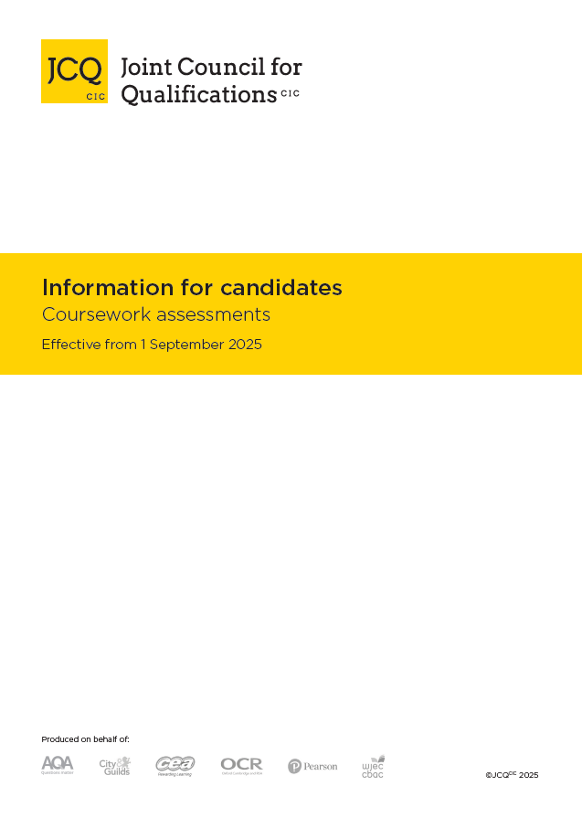

APPENDIX 2

JCQ Information for candidates – non-examination assessments
You must read this information if you are undertaking qualifications that contain components of non-examination assessment.
Please use the following link to view all JCQ Information for candidates documents including the JCQ Information for candidates- written exams https://www.jcq.org.uk/exams-office/information-for-candidates-documents/


APPENDIX 3

JCQ Information for candidates – on-screen tests
You must read this information if you will be taking any externally assessed on-screen tests as part of your qualification(s).
Please use the following link to view all JCQ Information for candidates documents including the JCQ Information for candidates- written exams https://www.jcq.org.uk/exams-office/information-for-candidates-documents/


APPENDIX 4

JCQ Information for candidates – written exams
You must read this information before you take any externally assessed written exams.
Please use the following link to view all JCQ Information for candidates documents including the JCQ Information for candidates- written exams https://www.jcq.org.uk/exams-office/information-for-candidates-documents/
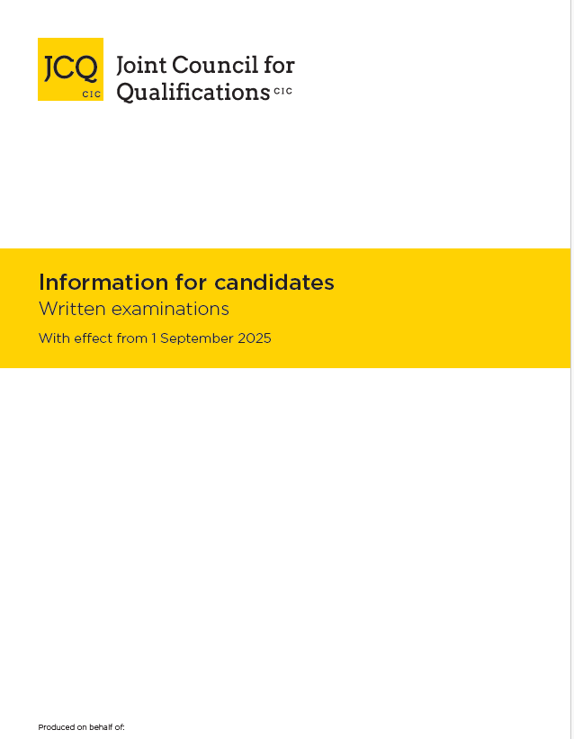

APPENDIX 5

JCQ Information for candidates – social media
You must read this information to help you stay within examination/assessment regulations when using social media. Please use the following link to view all JCQ Information for candidates documents https://www.jcq.org.uk/exams-office/information-for-candidates-documents/
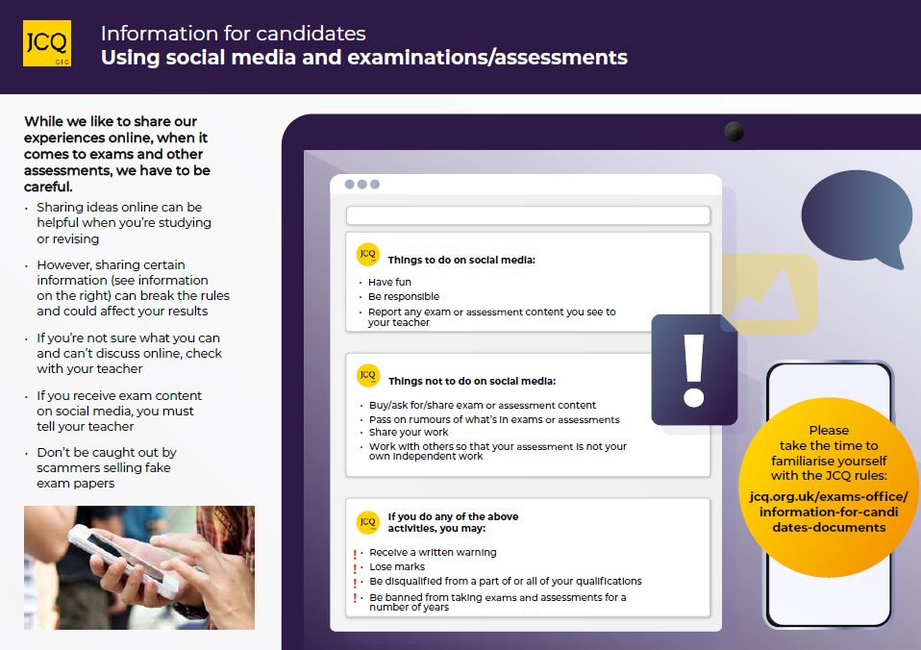

APPENDIX 6

JCQ Information for candidates - AI (Artificial Intelligence and assessments)
You must read this information to help you stay within examination/assessment regulations when using artificial intelligence. This information explains: What is AI? What is an AI tool? When can I use AI? When can I not use an AI tool? If I’m allowed to use AI, how is this breaking the rules? How to make sure you don’t misuse AI. The document can be found online using the following link: https://www.jcq.org.uk/exams-office/malpractice/ You will need to scroll down the page to view the document below.
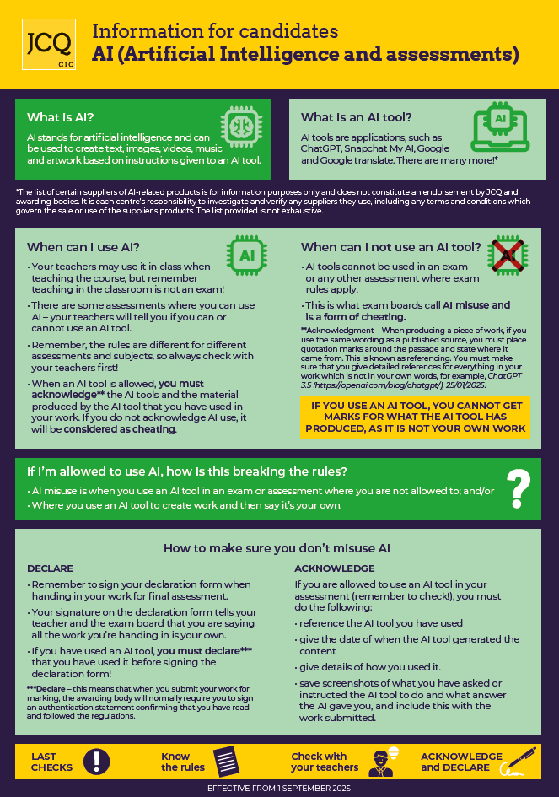

APPENDIX 7

JCQ Unauthorised items poster
This poster will be displayed outside each exam room. You must note that “Possession of unauthorised items, such as a mobile phone or any watch, is a serious offence and could result in DISQUALIFICATION from your examination and your overall qualification.”
The unauthorised items poster can be used online using the following link: https://www.jcq.org.uk/exams-office/exam-room-posters/



APPENDIX 8

JCQ Warning to candidates poster
This poster will be displayed outside each exam room. You must note all the warnings. If you wish to view this poster online, please use the following link: https://www.jcq.org.uk/exams-office/exam-room-posters/
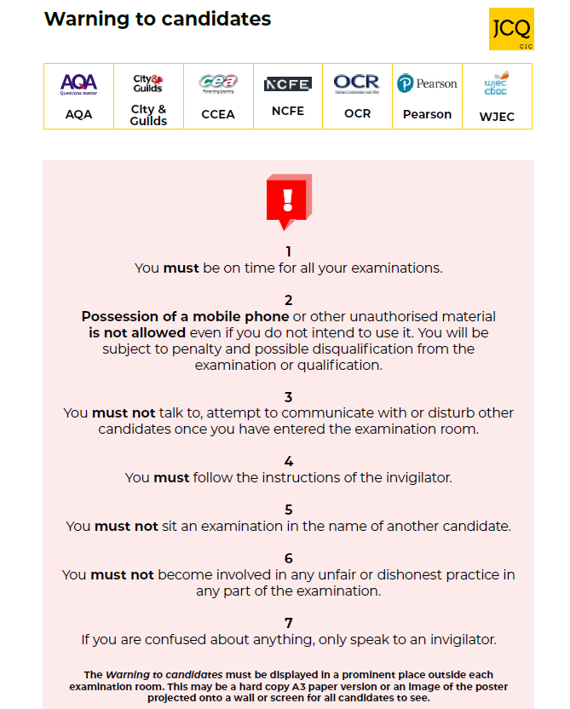

APPENDIX 9

JCQ AI poster for students
This poster is a quick guide to help you to better understand the rules for use of AI in assessments. An example poster below. The poster can also be viewed online using the following link: https://www.jcq.org.uk/wp-content/uploads/2024/02/JCQ-AI-poster-for-students-2.pdf

